SLIDE 1:

NAME HERE:

FIRST HOLY
COMMUNION

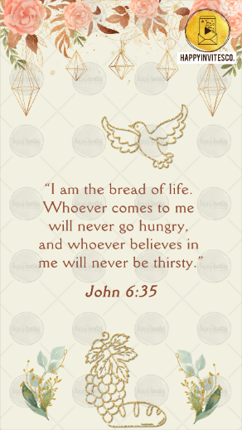
SLIDE 2:

“I am the bread of life.
Whoever comes to me
will never go hungry,
and whoever believes in
me will never be thirsty.”

John 6:35

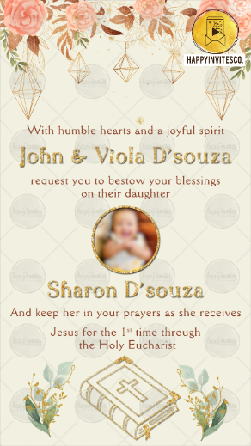
SLIDE 3:

With humble hearts and a joyful spirit her parents
Parents Name Here

request you to bestow your blessings on
Name Here

And keep her in your prayers as she receives
Jesus for the 1st time through
the Holy Eucharist

SLIDE 4:

Day:
Date:
Time:
Venue:

With best wishes,
Names Here

R.S.V.P. (If Any)

