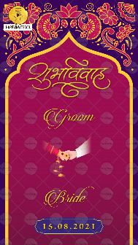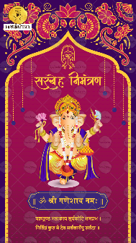
Slide 1:

Name of Groom:

Name of Bride:

Please specify whose name to come first? Bride or Groom?

Date of Wedding:

Slide 2: Matter as shown in slide

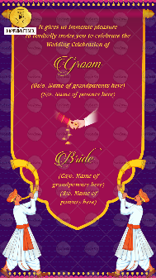
Slide 3:

It gives us immense pleasure
to cordially invite you at the
Wedding Celebration of

Name of Groom:
(Gs/o. Name of Grandparents - Optional)
(S/o. Name of parents)

Name of Bride:
(Gd/o. Name of Grandparents - Optional)
(D/o. Name of parents)

Please specify whose name to come first? Bride or Groom?

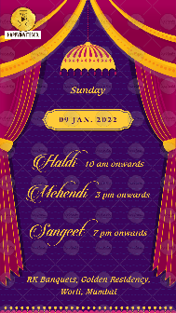
Slide 4:

Day:
Date:

Programme for the Day

Venue:

Slide 5:

Day:
Date:

Programme for the Day

Venue:

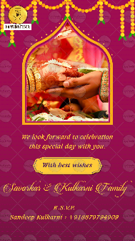
Slide 6:

We look forward to celebrating
this special day with you.

With best wishes
Name of Family here

R.S.V.P.
Contact details here

If you want to replace this photo with some other photo – email us photo on happyinvites.co@gmail.com

