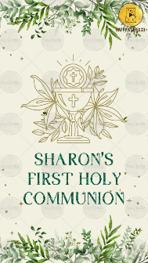
SLIDE 1:

NAME HERE:
SHARON’S

FIRST HOLY
COMMUNION

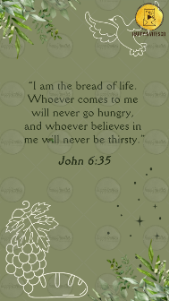
SLIDE 2:

“I am the bread of life.
Whoever comes to me
will never go hungry,
and whoever believes in
me will never be thirsty.”

John 6:35

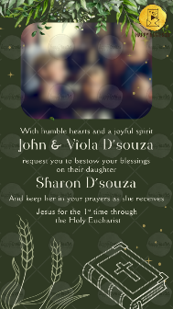
SLIDE 3:

With humble hearts and a joyful spirit
John & Viola D’souza

request you to bestow your blessings
on their daughter
Sharon D’souza

And keep her in your prayers as she receives
Jesus for the 1st time through
the Holy Eucharist

SLIDE 4:

Day,
Date

Time

Venue:

With best wishes,

R.S.V.P.

