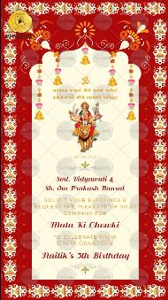
SLIDE 1:

|| सर्वमंगल मांगल्ये शिवे सवार्थ साधिके
शरण्येत्र्यंबके गौरी नारायणी नमोस्तुते ||

|| JAI MATA DI ||

Smt. Vidyawati & Sh. Om Prakash Bansal

solicit your blessings &
request the pleasure of your company for

Mata Ki Chowki

to celebrate & welcome their granddaughter/ grandson
Function Title’s Occasion here
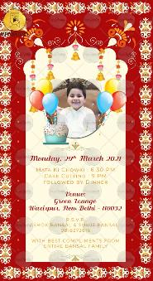

Monday, 29th March 2021

Mata Ki Chowki : 60 PM
Cake Cutting : 9 PM
followed by Dinner

Venue:
Green Lounge
Wazirpur, New Delhi - 110052

R.S.V.P.
Ashok Bansal & Sumit Bansal : 9818373616

With Best Compliments from entire Bansal Family

