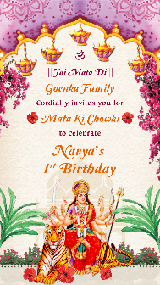
SLIDE 1:

|| JAI MATA DI ||

Goenka Family

Cordially invites you for

Mata Ki Chowki

to celebrate

Function Title’s Occasion here
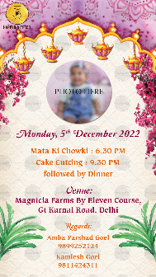

Email one photo on happyinvites.co@gmail.com

Monday, 29th March 2022

Mata Ki Chowki : 6.30 PM
Cake Cutting : 9.30 PM
followed by Dinner

Venue:
Green Lounge
Wazirpur, New Delhi - 110052

R.S.V.P.
Ashok & Sumit Bansal : 9818373616

With Best Compliments from
entire Bansal Family

