SLIDE 1 & SLIDE 2

|| Sri Ganeshaya Namaha ||

Parents Name

request the pleasure of your presence
on the auspicious occasion of the
Upanayanam Ceremony
of their son

EMAIL PHOTO ON happyinvites.co@gmail.com

NAME HERE

SLIDE 3

Grandson of

Name of Grandparents here:

SLIDE 4

Title of the function:
Upanayanam
Ceremony

On Day:
Date:

Time:

At Venue:

SLIDE 5

We look forward to seeing you

Names here

Save the date &
Let’s Celebrate!

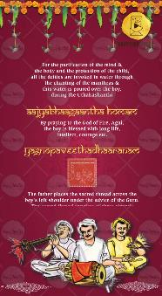

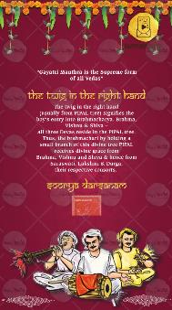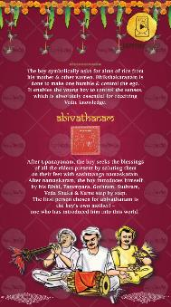

THESE SLIDES WILL COME AS SHOWN BY DEFAULT
NO KIND OF EDITS ARE POSSIBLE

If anything to be done, please let us know, we will check and let you know if possible and extra cost for it.

