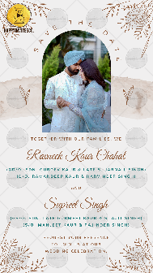
Ek Onkar

Shabad Lines:

SAVE THE DATE

Together with our families, we

Name of Bride:
(GD/O. Name of grandparents)
(D/O. Name of parents)

AND

Name of Groom:
(GS/O. Name of grandparents)
(S/O. Name of parents)

REQUEST YOUR PRESENCE
TO JOIN US AT OUR
WEDDING CELEBRATION.

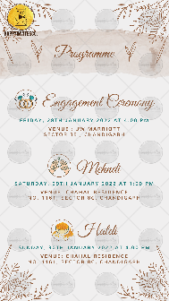

Programme:

Title of the Function:
Day, Date:
Time:
Venue:

Title of the Function:
Day, Date:
Time:
Venue:

Title of the Function:
Day, Date:
Time:
Venue:

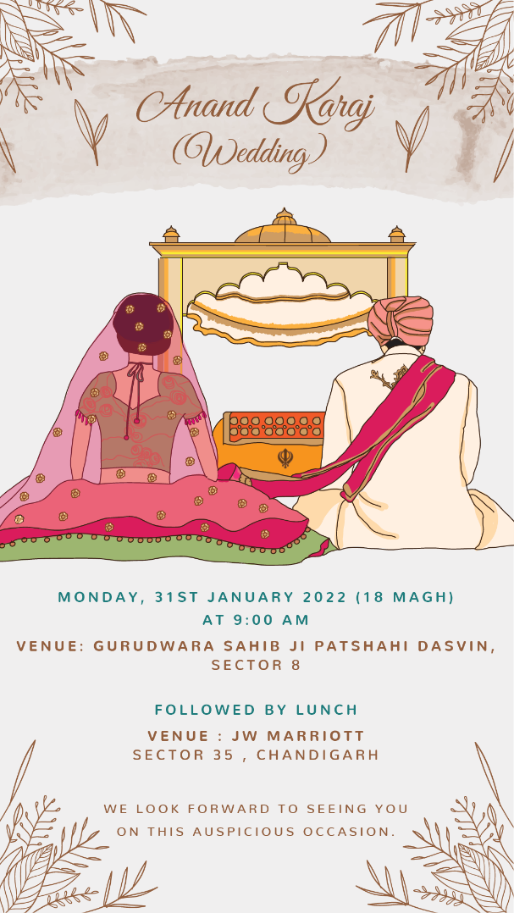

Title of the Function:
Day, Date:
Time:
Venue:

With best wishes,

R.S.V.P.

