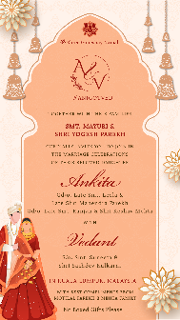
PAGE 1:
God’s Icon
Name of God

Logo email on happyinvites.co@gmail.com | Hashtag if any

Together with their families

Name of Parents here

cordially invite you to join in
the wedding celebrations
of their daughter

Name of Bride:
Gd/o. Name of grandparents here:

with

Name of Groom:
Gs/o. Name of Grandparents here:
S/o. Name of Parents here:

Venue: only if destination

With best compliments from,
Name of Family here

No Boxed Gifts Please

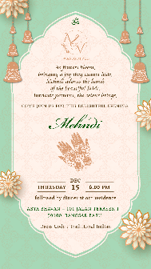
PAGE 2:

As flowers bloom,
bringing a joy they cannot hide,
Mehndi adorns the hands
of the beautiful bride.
Intricate patterns, the colour brings.

COME JOIN US FOR THE DELIGHTFUL EVENING

Mehndi

DAY
DATE

TIME
VENUE

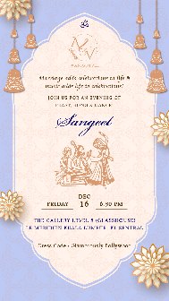
PAGE 3:

Marriage adds celebrations to life &
music adds life to celebrations!

JOIN US FOR AN EVENING OF
FEAST, SONG & DANCE!

Sangeet

DAY
DATE

TIME
VENUE

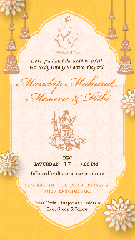
PAGE 4:

Have you heard the wedding bells?
Get ready with your attire, they tell!

Mandap Muhurat,
Mosaru & Pithi

DAY
DATE

TIME
VENUE

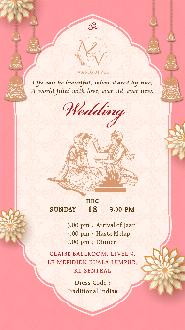
PAGE 5:

Life can be beautiful, when shared by two,
A world filled with love, ever old, ever new.

Wedding

DAY
DATE

TIME
VENUE

