Slide 1:

Name of Kid/ Kids:

Function title:
Navjote Ceremony

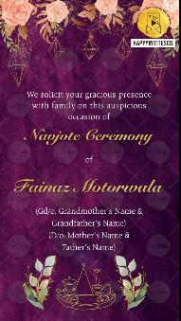
Slide 2:

We solicit your gracious presence
with family on this auspicious occasion of

Navjote Ceremony

of

Name of Kid/ Kids:

Gs/o. Gd/o.
Name of grandparents:

S/o. D/o.
Name of parents here:

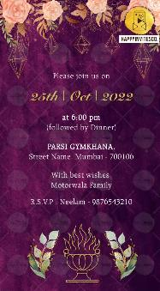
Slide 3:

Please join us on

Day:
Date:

Time:

Venue:

With best wishes,
Family Names/ Name of Family members

RSVP
Details here

