

Slide 1:

Navratri

Invitation

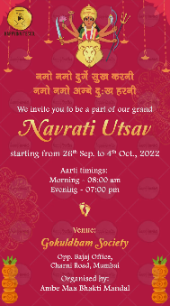

Slide 2:

ueks ueks nqxsZ lq[k djuhueks ueks vEcs nq%[k gjuh



We invite you to be a part of our grand

Navratri Utsav

Starting from 26th Sep. to 4th Oct., 2022

Aarti timings:

Morning - 08.00 am

Evening - 07.00 pm

Venue:

Address here

Organised by: