HW34 – Royal Indian Wedding Invitation Video
Slide 1:
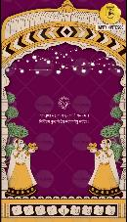
Ganpati Icon
Ganpati Shloka
Slide 2:
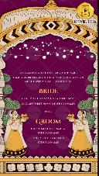
With an ecstatic heart, we solicit your
gracious presence on the auspicious occasion
of the Wedding Celebration of
Bride Name:
Bride’s Grandparents Name:
Bride’s Parents Name:
Weds
Groom Name:
Bride’s Grandparents Name:
Bride’s Parents Name:
Whose name should come first? (Bride/Groom):
Slide 3:
Event Title: Wedding Ceremony
Date:
Day:
Time:
Venue:
Slide 4:
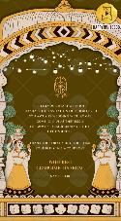
It fills our heart with joy to share the invitation of our beloved
son Aayush’s wedding with Komal.
Come join us as they begin the most special journey of their
life together.
Thank You for sharing your time, your blessings & your love
With best compliments from:
Names Here

