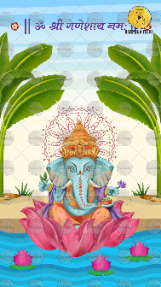
Slide 1:

|| ૐ श्री गणेशाय नमः ||

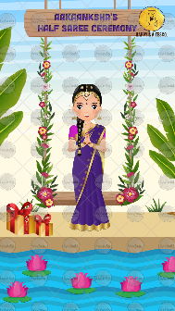
Slide 2:

Name of Girl:
Function Title: Half Saree Ceremony

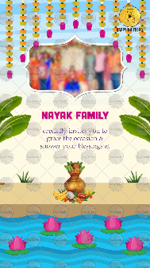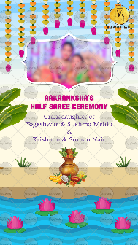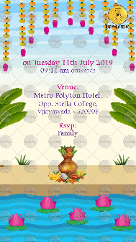
Slide 3, 4 & 5:

Part 1:

Name of Inviters/ Name of Family/ Name of Memebers:

cordially invites you to
grace the occasion &
shower your blessings at

Part 2:
Name of Girl:
Function Title: Half Saree Ceremony

Granddaughter of
Name of Grandparents here:

Daughter of
Name of Parents here:

Part 3:
On Day:
Date:

Time:

Venue:

R.S.V.P.

