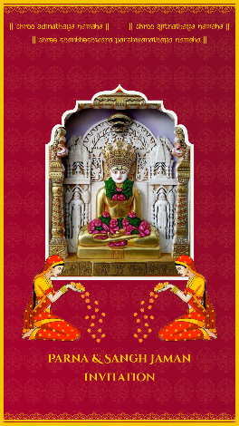
SLIDE 1:

Gods’ & gurus’ names as per whatever you need

|| Shree Adinathaya Namaha ||
|| Shree Ajitnathaya Namaha ||
|| Shree Shankheshwara Parshwanathaya Namaha ||

Parna & Sangh Jaman
Invitation
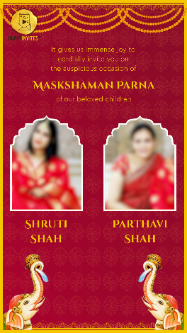
SLIDE 2:

It gives us immense joy to
cordially invite you on
the auspicious occasion of

Maskshaman Parna

of our beloved children

Email photo on happyinvites.co@gmail.com

Name/ Names here:

Grandparents - optional
Parents – optional

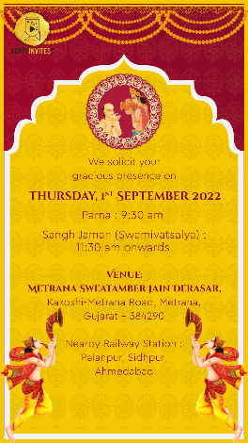
SLIDE 3:

We solicit your
gracious presence on

Day, Date:

Programme Timings:

Venue:

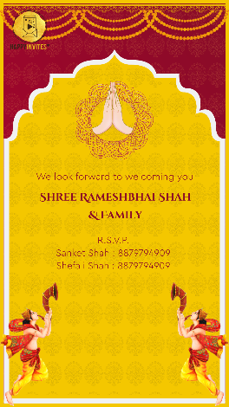
SLIDE 4:

We look forward to welcoming you

Name of Family

R.S.V.P.

