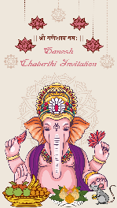



Ganesh

Chaturthi Invitation

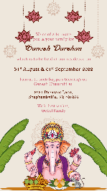

We cordially invite

you & your family for

**\*\*Ganesh Darshan\*\***

to be held at Our Residence from

**\*\*10th - 12th September 2021\*\***

**\*Timings if needed\*\***

Join us to seek Bappa’s blessings on

Ganesh Chaturthi at

**\*\*Venue here\*\***

With best wishes,

**\*\*Family Name here\*\***