HW29 – Wedding Invitation Video

Slide 1A & 1B:
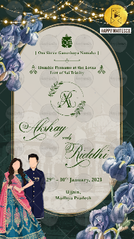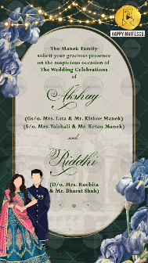

God Icon:
God Name:

LOGO IF ANY – PLEASE EMAIL ON HAPPYINVITESCO@GMAIL.COM
Logo designing will be chargeable if to be done from our end

Date/ Date Range: OPTIONAL
Venue: ONLY INF DESTINATION

The Name of Family here
solicit your gracious presence
on the auspicious occasion of the
Wedding Celebration
of

Bride Name:
Bride’s Parents Name:
Bride’s Grandparents name:
and

Groom Name:
Groom’s Parents Name:
Groom’s Grandparents name:

Whose name should name first (Bride/Groom):

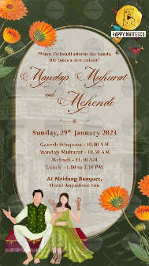
Slide 2:
‘When Mehendi adorns the hands, life takes a new colour.’

Function Title:
Mehndi

Day:
Date:
Time:
Venue:

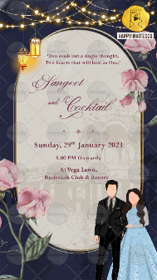
Slide 3:
‘Two souls but a single thought, two hearts that will beat as One.’
Function Title:
Sangeet & Cocktail

Day:
Date:
Time:
Venue:

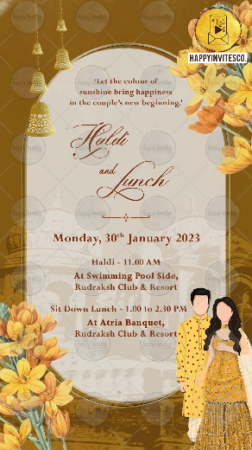
Slide 4:
‘Let the colour of sunshine bring happiness in the couple’s new beginning.’
Function Title:
Haldi

Day:
Date:
Time:
Venue:

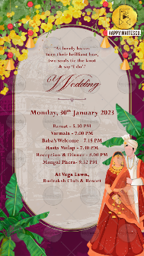
Slide 5:
‘As lovely leaves
turn their brilliant hue,
two souls tie the knot
& say ‘I do’.’

Function Title:
Wedding Ceremony

Day:
Date:
Time:
Venue:

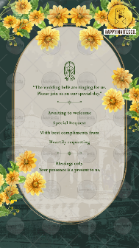
Slide 6:

Namaste Icon

“The wedding bells are ringing for us.
Please join us on our special day.”

Title: Awaiting to welcome
Names:

Title: Special Request
Names:

Title: With best compliments from
Names:

Title: Heartily requesting
Names:

Blessings only.
Your presence is a present to us.

