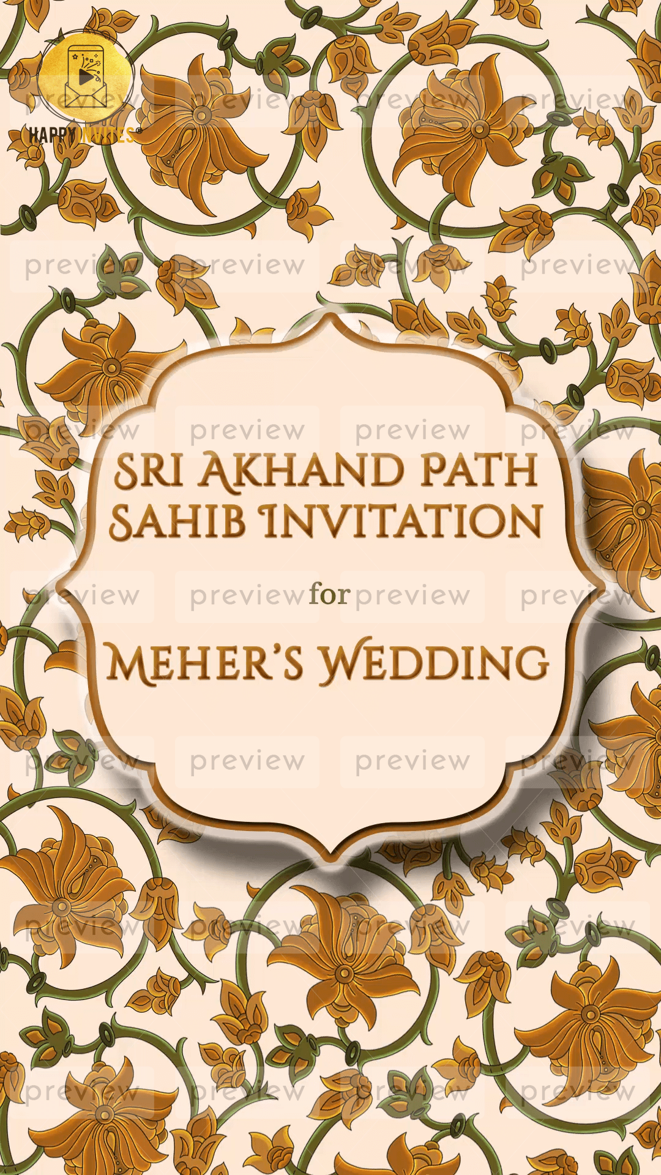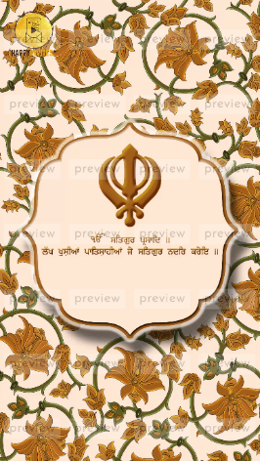
Slide 1 & Slide 2:

Title of the Ritual:
Sri Akhand Path Sahib Invitation

for

Function Title:
Meher’s Wedding

-

Khand Symbol

Gurbani Line as per video invite or whatever you wish to share

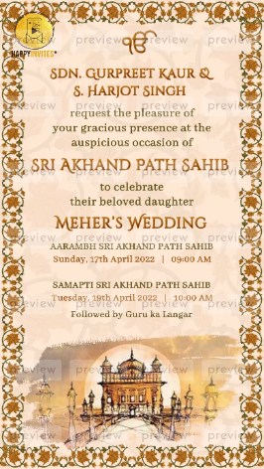
Slide 3:

Ek onkar symbol

Name of Family or Parents:

request the pleasure of
your gracious presence at the
auspicious occasion of

Title:
Sri Akhand Path Sahib/ Shri Sukhmani Sahib Path

to celebrate their beloved daughter

Title of Function:
Meher’s Wedding

Aarambh Sri Akhand Path Sahib
Day:
Date:
Time:

Samapti Sri Akhand Path Sahib
Day:
Date:
Time:

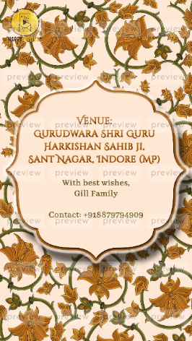
Slide 4:

Venue:

With best wishes,

Contact:

