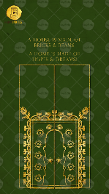
Slide 1:

A house is made of
Bricks & Beams,
A home is made of
Hopes & Dreams.

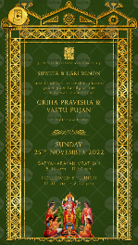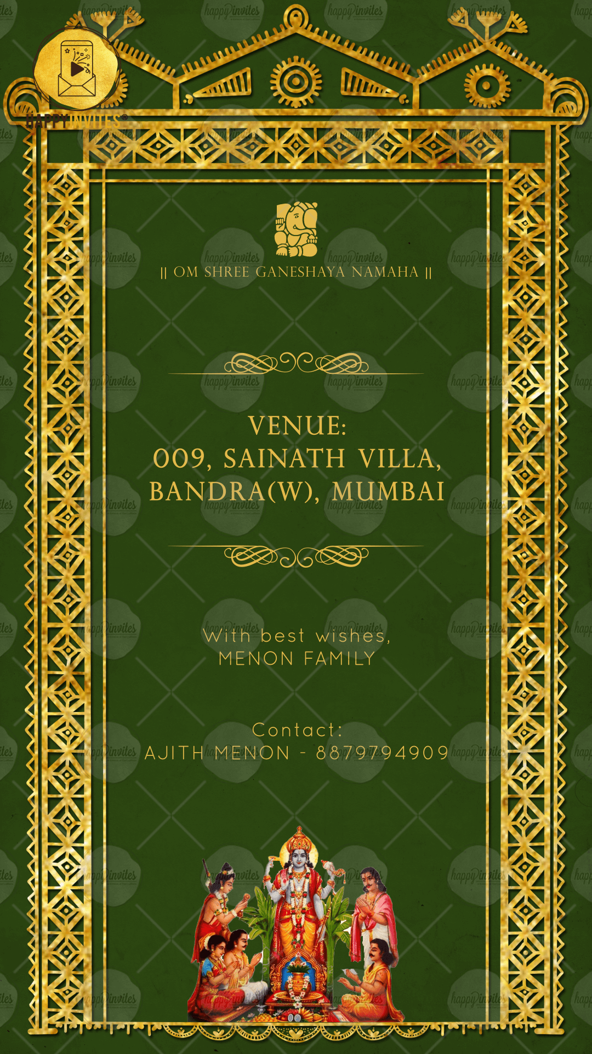
Slide 2 & Slide 3:

Ganeshji symbol
|| Om Shree Ganeshaya Namaha ||

Name of Inviters:

are delighted to cordially invite
you & your family at the
auspicious occasion of

Function Title:
GRIHA PRAVESH & VASTI PUJAN

DAY:
DATE:

TIME:

Venue:

With best wishes,

Contact No.:

