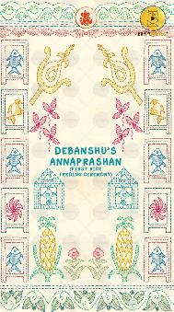
SLIDE 1:

TITLE OF THE FUNCTION:

DEBANSHU’S
ANNAPRASHAN
(First Rice
Feeding Ceremony)

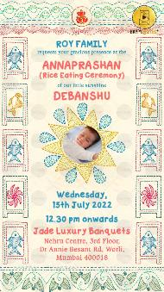
SLIDE 2:

NAME OF FAMILY:
ROY FAMILY

Requests your gracious presence at the

TITLE OF THE FUNCTION:
ANNAPRASHAN
(Rice Eating Ceremony)

of our little sunshine

NAME OF THE BABY:

DAY,
DATE:

TIME:

VENUE:

EMAIL PHOTO ON HAPPYINVITES.CO@GMAIL.COM WITH ORDER NUMBER WITH THIS FORM ATTACHED

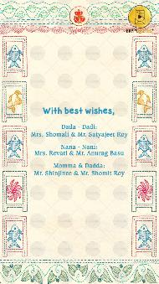
SLIDE 3:

With best wishes,

Dada - Dadi:

Nana - Nani:

Momma - Dadda:

