Slide 1:

Function Title:
50th Wedding
Anniversary Celebration

Poem Lines:
The Golden bells
are about to ring,
on a day so special,
let’s rejoice & sing!

Every Anniversary
is a tribute to the
Love a couple shares…

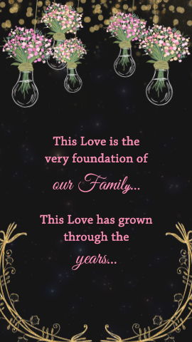
Slide 2:

This Love is the
very foundation of
our Family…

This Love has grown
through the
years…

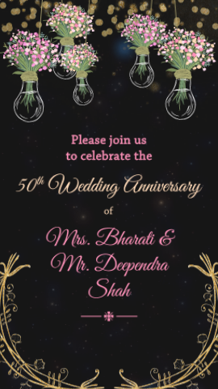
Slide 3:

Please join us
to celebrate the

Function Title:
50th Wedding Anniversary

of

Name of Couple:

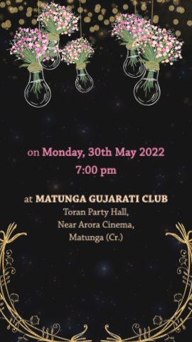
Slide 4:

on
Day:
Date:
Time:

at
Venue:

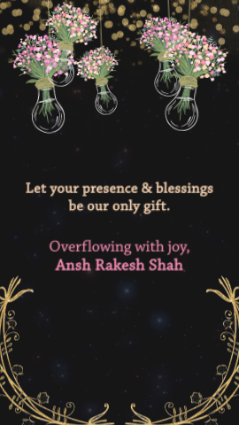
Slide 5:

Let your presence & blessings
be our only gift.

Overflowing with joy,
Name here

