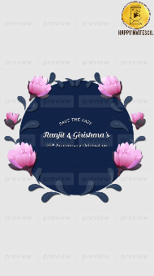
Slide 1:

SAVE THE DATE

Ranjit & Girishma’s

25th Anniversary Celebration

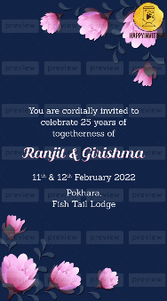
Slide 2:

You are cordially invited to
celebrate 25 years of
togetherness of

Ranjit & Girishma

11th & 12th February 2022
Pokhara, Fish Tail Lodge

Slide 3:-
An evening of music, dance &
scrumptious food!

BBQ Night

11th February 2022, Friday
6 pm onwards

Dress Code: Smart Western

Slide 4:-

Love is in the Air!

12th February 2022, Saturday

Phir se Phere!
10 am onwards
Dress Code: Maroon

Valentine’s Night
6 pm onwards
Dress Code: Men in Black & Women in Red

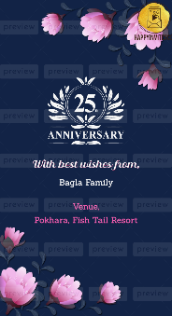
Slide 5
In circle 25TH ANNIVERSARY CELEBRATION Monogram

With best wishes from,
Bagla Family

Venue,
Pokhara, Fish Tail Resort

