RHW – Animated Hindu Wedding Invitation

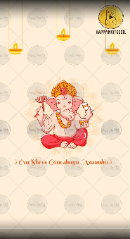
Slide 1: Vakratunda Shloka music
|| Om Shree Ganeshaya Namaha ||

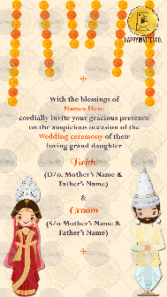
Slide 2:

We cordially invite you
on the auspicious occasion
to the Wedding Ceremony
of

Bride Name
(Gd/o. Name of grandparents)
(D/o. Name of Parents)

With

Groom Name
(Gs/o. Name of grandparents)
(S/o. Name of Parents)

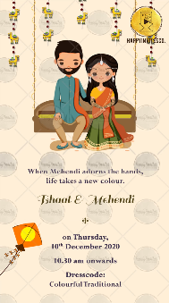
Slide 3:

When Mehendi adorns the hands,
Life takes a new colour.

Function Name:
Day:
Date:
Time:
Venue:

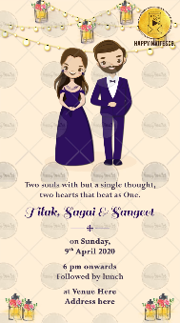

Slide 4:

Two souls but a single thought,
Two hearts that beat as one.

Function Name:
Day:
Date:
Time:
Venue:

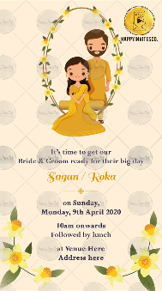
Slide 5:

Let the colour of sunshine bring happiness
In the couple’s new beginning.

Function Name:
Day:
Date:
Time:
Venue:

Slide 6:

Let’s get the celebrations started,
by kicking up our heels & grooving at

Function Name:
Day:
Date:
Time:
Venue:

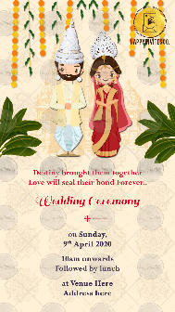
Slide 7:

Destiny brought them together &
now Love will seal their bond Forever…

Function Name:
Day:
Date:
Time:
Venue:

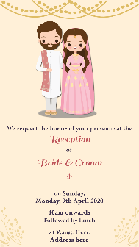
Slide 8:

Cheers to love, laughter & Happily Ever After.

Function Name:
Day:
Date:
Time:
Venue:

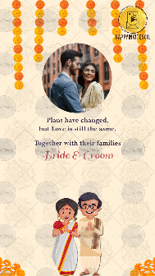
Slide 9:

With best wishes,
Names here

RSVP

Email us 1 good resolution photo at happyinvites.co@gmail.com

