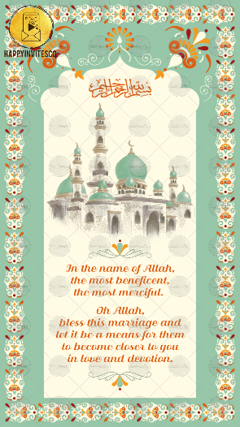
SLIDE 1:

Arabic Symbol on top

In the name of Allah,
the most beneficent,
the most merciful.

Oh Allah,
bless this marriage and
let it be a means for them
to become closer to you in
love and devotion.

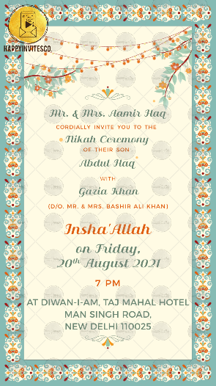
SLIDE 2:

Name of Parents:

CORDIALLY INBITE YOU TO THE

Occasion Title:

OF THEIR SON/ DAUGHER

Name of Groom/ Bride:

WITH

Name of Groom/ Bride:

Function Title:

on Day:
Date:

Time:

Venue:

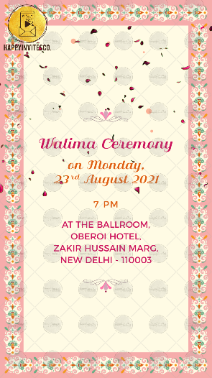
SLIDE 3:

Function Title:

on Day:
Date:

Time:

Venue:

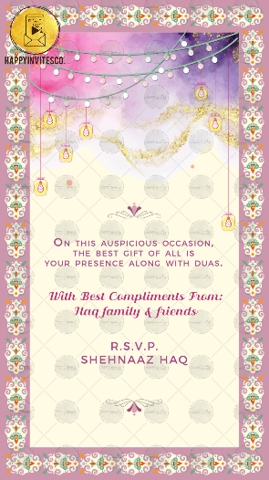
SLIDE 4:

ON THIS AUSPICIOUS OCCASION,
THE BEST GIFT OF ALL IS
YOUR PRESENCE ALONG WITH DUAS.

With Best Compliments From:
Names here:

R.S.V.P. (optional)
Details here:

