SLIDE 1:-
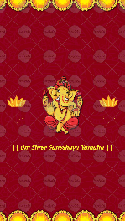
|| Om Shree Ganeshaya Namaha ||

SLIDE 2:-
Let’s Celebrate with
Pathak’s & Randhawa’s

SLIDE 3:-
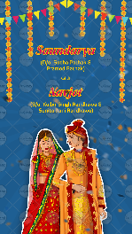
Bride Name:
Bride’s Parents Name:

With

Groom Name
Groom’s Parents Name:

Whose name should come first? Bride/Groom

SLIDE 4:-
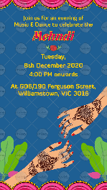
Function Name:
Day:
Date:
Time:
Venue:
-

SLIDE 5:-
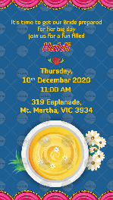
Function Name:
Day:
Date:
Time:
Venue:
-

SLIDE 6:-
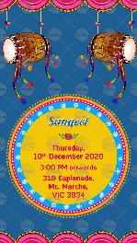
Function Name:
Day:
Date:
Time:
Venue:
-

SLIDE 7:-
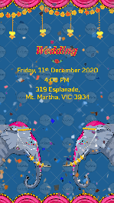
Function Name:
Day:
Date:
Time:
Venue:
-

SLIDE 8:-
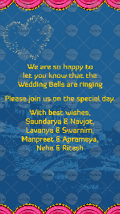
We are so happy to let you know that the
Wedding Bells are ringing.

Please join us on the special day.

With best wishes
Names here

See you at the
Wedding!

