SLIDE 1:-
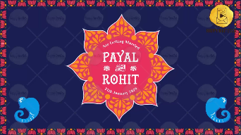
1st : Date of the Function: 4th February, 2021

Name of Bride: PUJA
Name of Groom: DEBADITYA
Whose name should come first? BRIDE

are getting married!

SLIDE 2:-
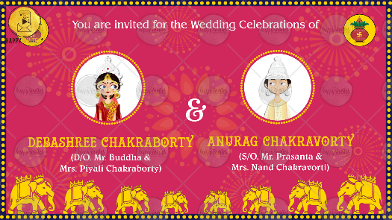
You are invited for the Wedding Celebrations of

Name of Bride: Puja Chakraborty
D/O. Mr. Buddhadeb & Mrs. Piyali Chakraborty

Name of Groom: Debaditya Chakravorty
S/O. Mr. Prasanta & Mrs. Nandita Chakravorti

SLIDE 3:-
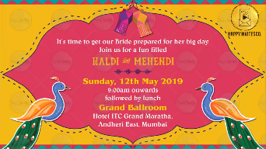
Two hearts will now beat as One.
As the bride & groom exchange rings, join us for their

Engagement

Sunday, 24th January 2021
6:15 PM onwards

Imperiah Banquet, 43 A,
Tollygunge Circular Road, Mahendra Tower,
Ground Floor, Near Mahavire Talla

SLIDE 4:-
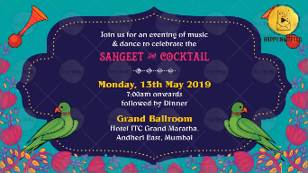
Destiny brought them Together, Love will seal their bond Forever.
Join us to celebrate their

Wedding

Thursday, 4th February 2021
6:00 PM onwards

“ROY BARI”, 192D,
N.S.C. Bose Road, Regent Park, Kolkata - 700040

SLIDE 5:-
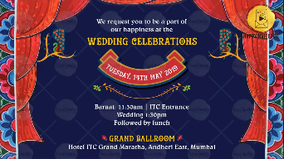
It’s time to celebrate the lovely couple’s
Love, Laughter & Happily Ever After.

Reception

Sunday, 7th February 2021
6:00 PM onwards

Xanadu, Community Hall, 10th Floor,
AS/275, Jogardanga, Rajarhat Main Road, Kolkata – 700136

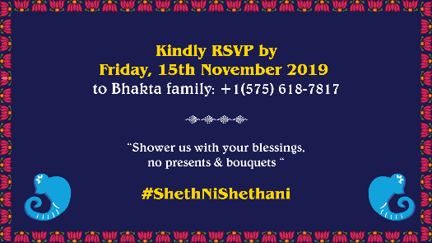
SLIDE 6:

With best wishes

