Thumbnail Cover:

Name here’s
Thread Ceremony
Invitation

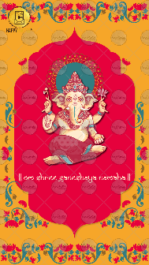
Slide 1:
Title of your god’s name or
|| Om Shree Ganeshaya Namaha ||
Slide 2:

With the divine grace of
Name of your god- if needed or this line will be removed

GOPALKRISHNAN FAMILY
heartily welcomes you to

Name here’s
Upanayanam

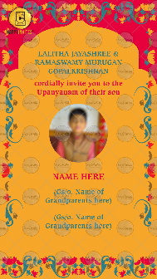
Slide 3:

Name of Parents

Cordially invite you to the
*Function Title here* of their son

Email 1 photo on happyinvites.co@gmail.com

NAME HERE

Name of grandparents:
(Gs/o. )
(Gs/o. )

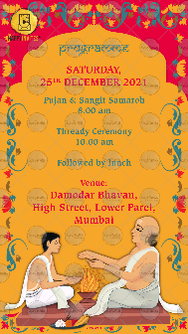
Slide 4:

Programme
Day,
Date

Time:

Venue:

Slide 5:

We look forward to seeing you

With best wishes,

R.S.V.P.

