SLIDE 1:
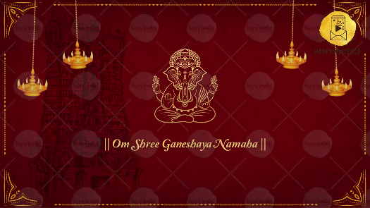

Line 1: || Om Shree Ganeshay Namah ||

-

SLIDE 2:
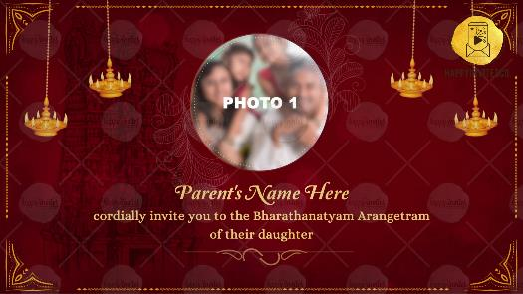

Parent’s Name Here
Cordially invite you to the Bharathanatyam Arangetram
of their daughter

-

SLIDE 3:

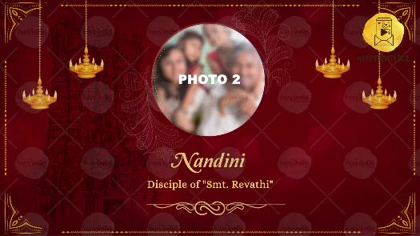
Girl Name:
Disciple Name:

SLIDE 4:

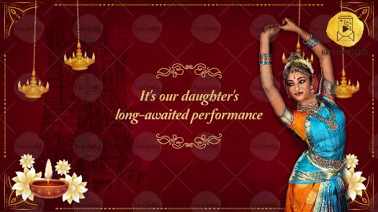

It's our daughter's long-awaited performance

SLIDE 5:

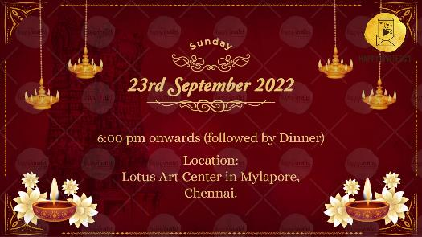
Date:
Time:
Venue:

SLIDE 6:

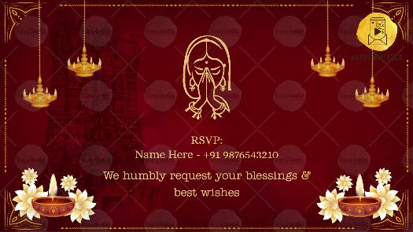
RSVP Details & With Best Wishes names(If any)
We humbly request your blessings & best wishes

