SLIDE 1:
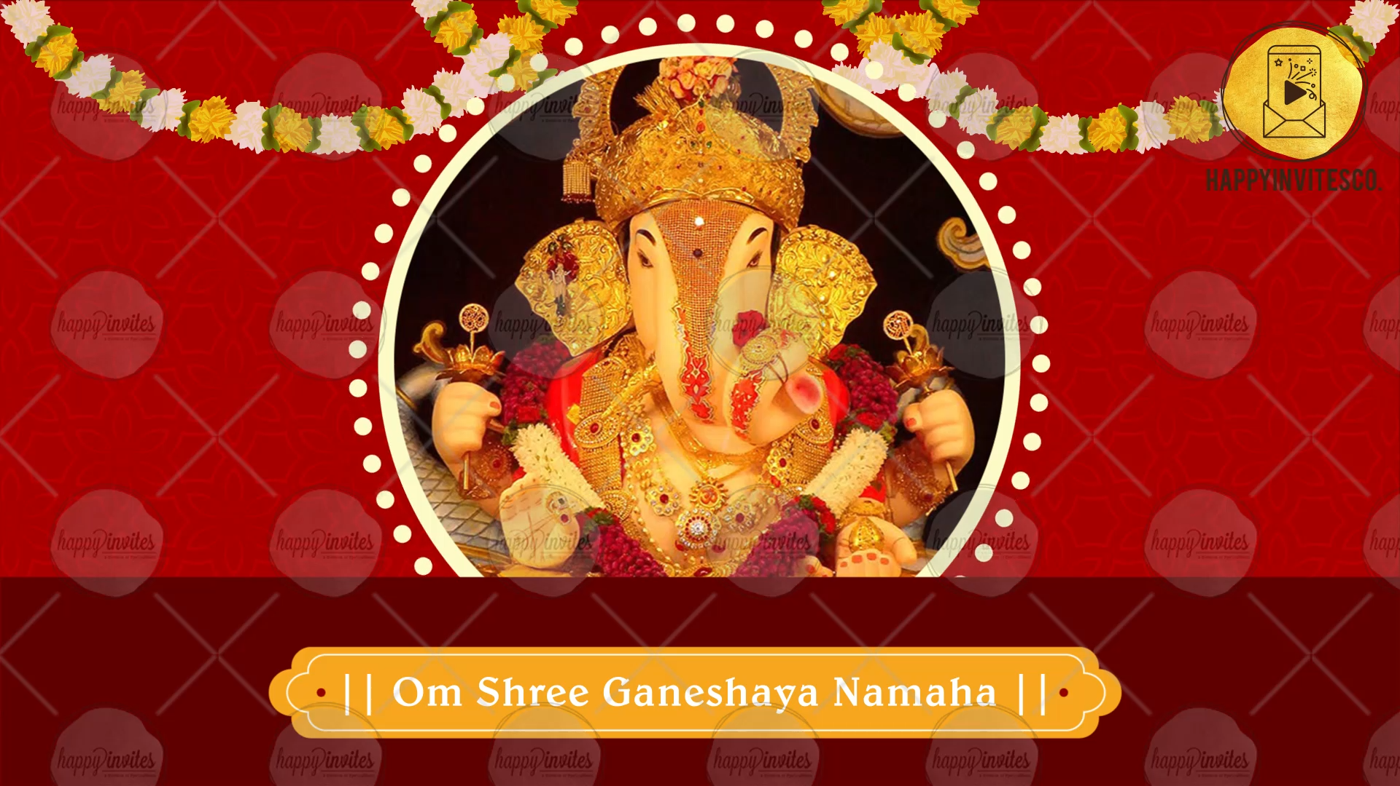
Line 1: || Om Shree Ganeshay Namaha ||

-

SLIDE 2:
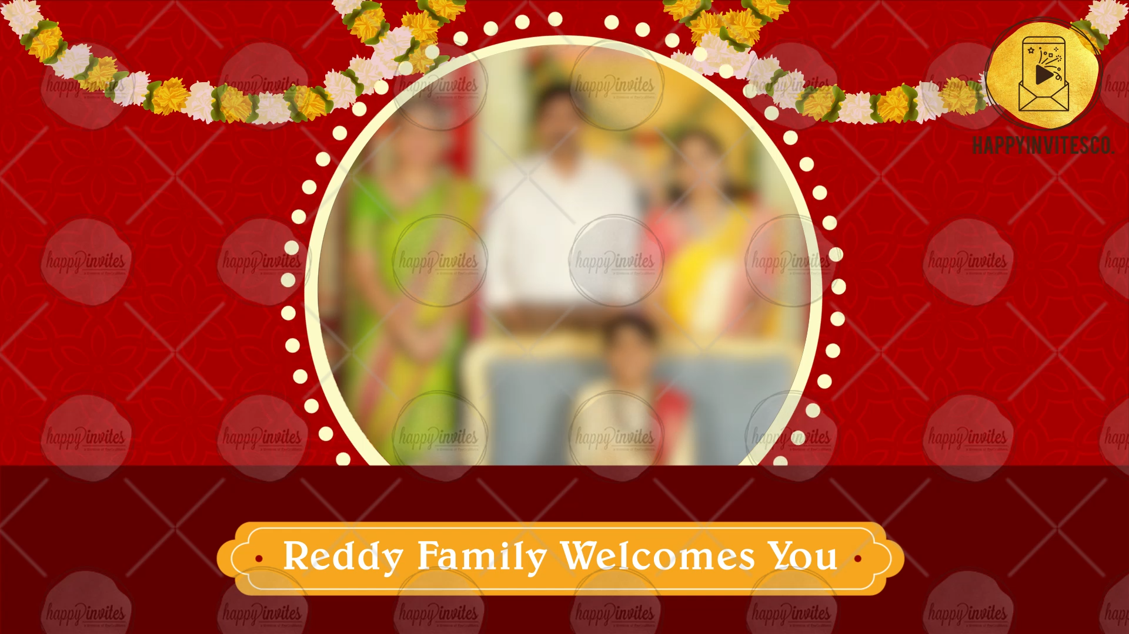
Line 1: Reddy Family Welcomes you
Mail us 1 photo at happyinvites.co@gmail.com
-

SLIDE 3:
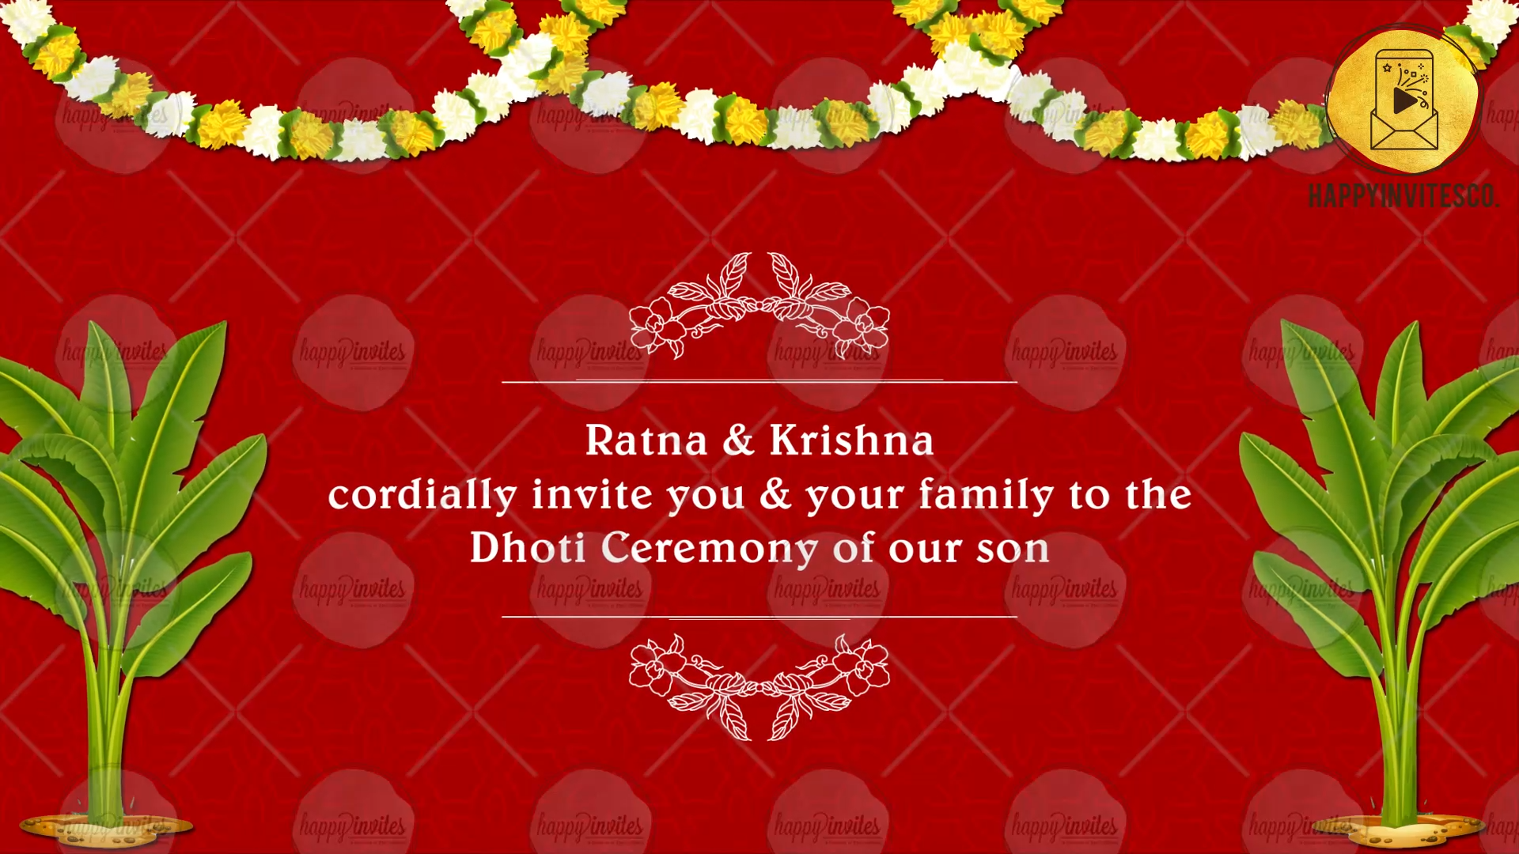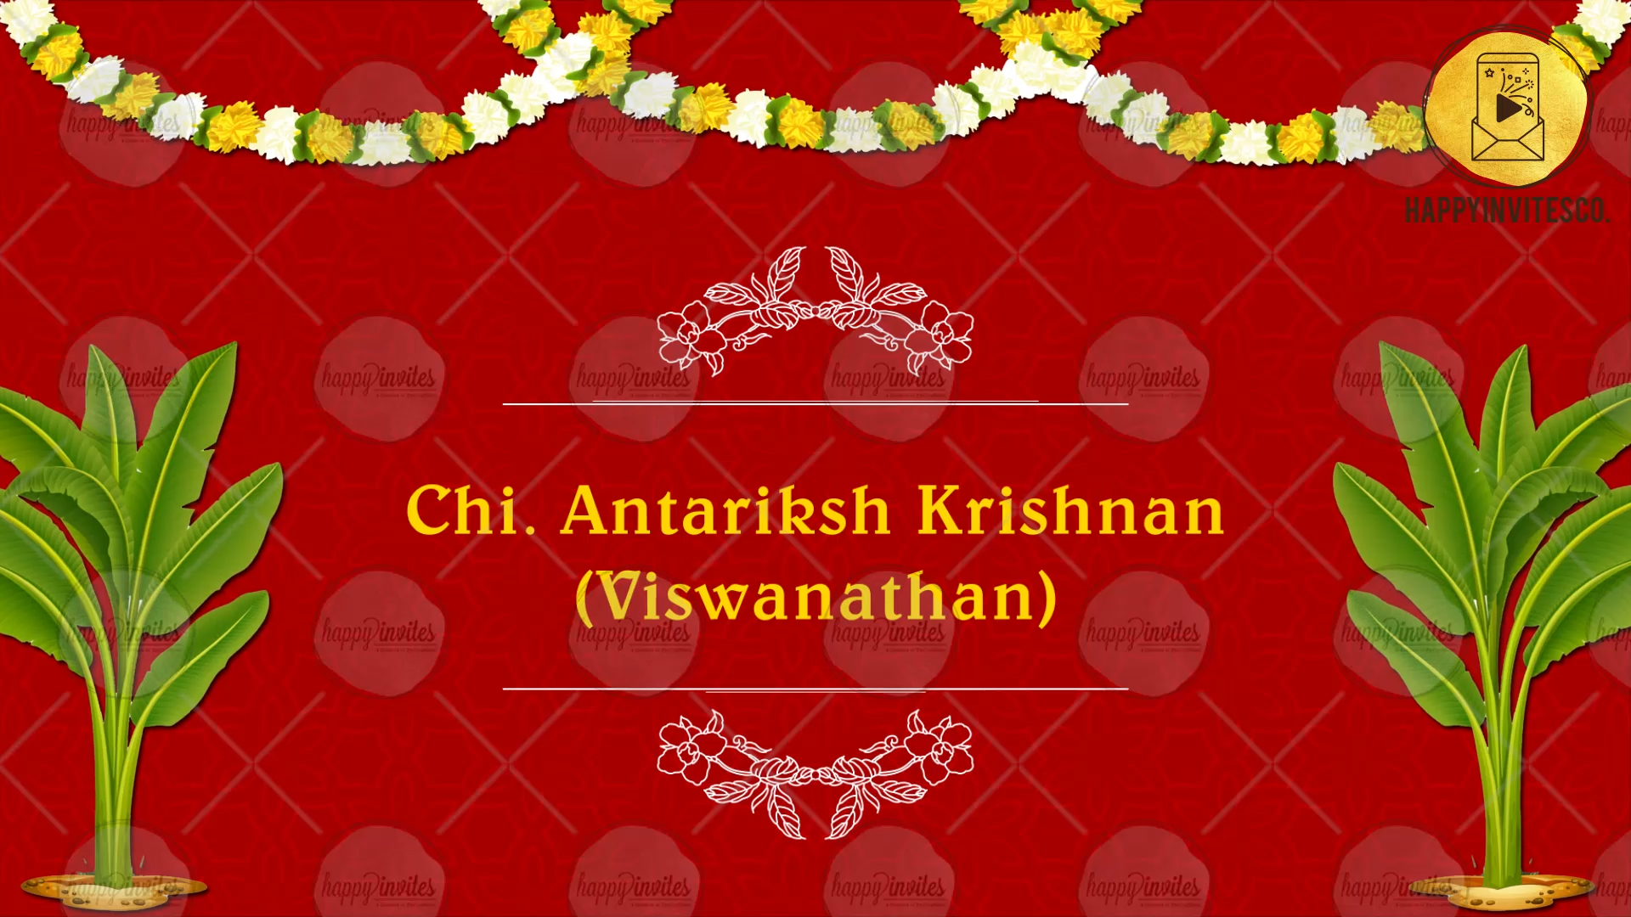
Line 1: Ratna & Krsihna
Cordially invite you & your family to the
Dhoti Ceremony of their Son

Line 2: Chi. Antariksh Krishnan (Viswanathan)

SLIDE 4:
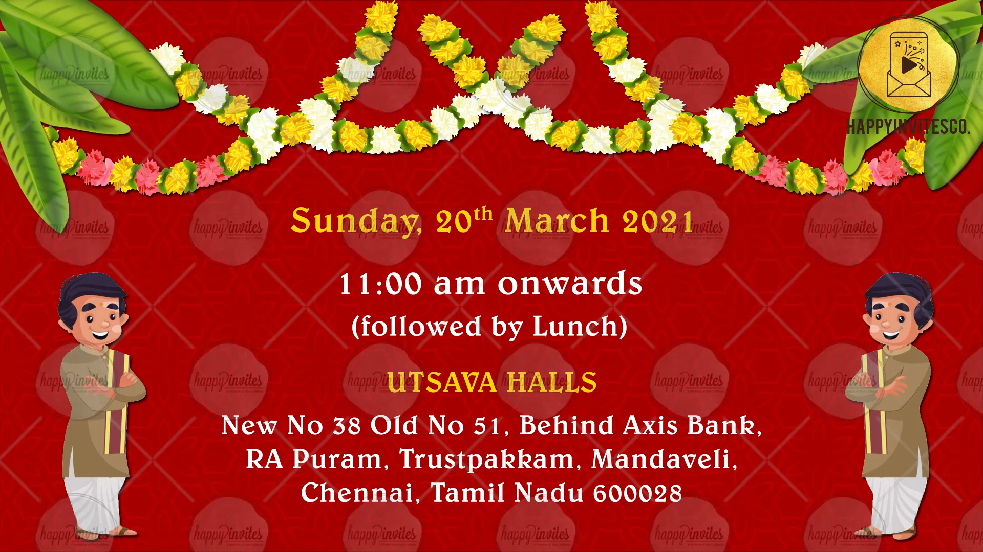
Date:
Time:
Venue:

SLIDE 5:
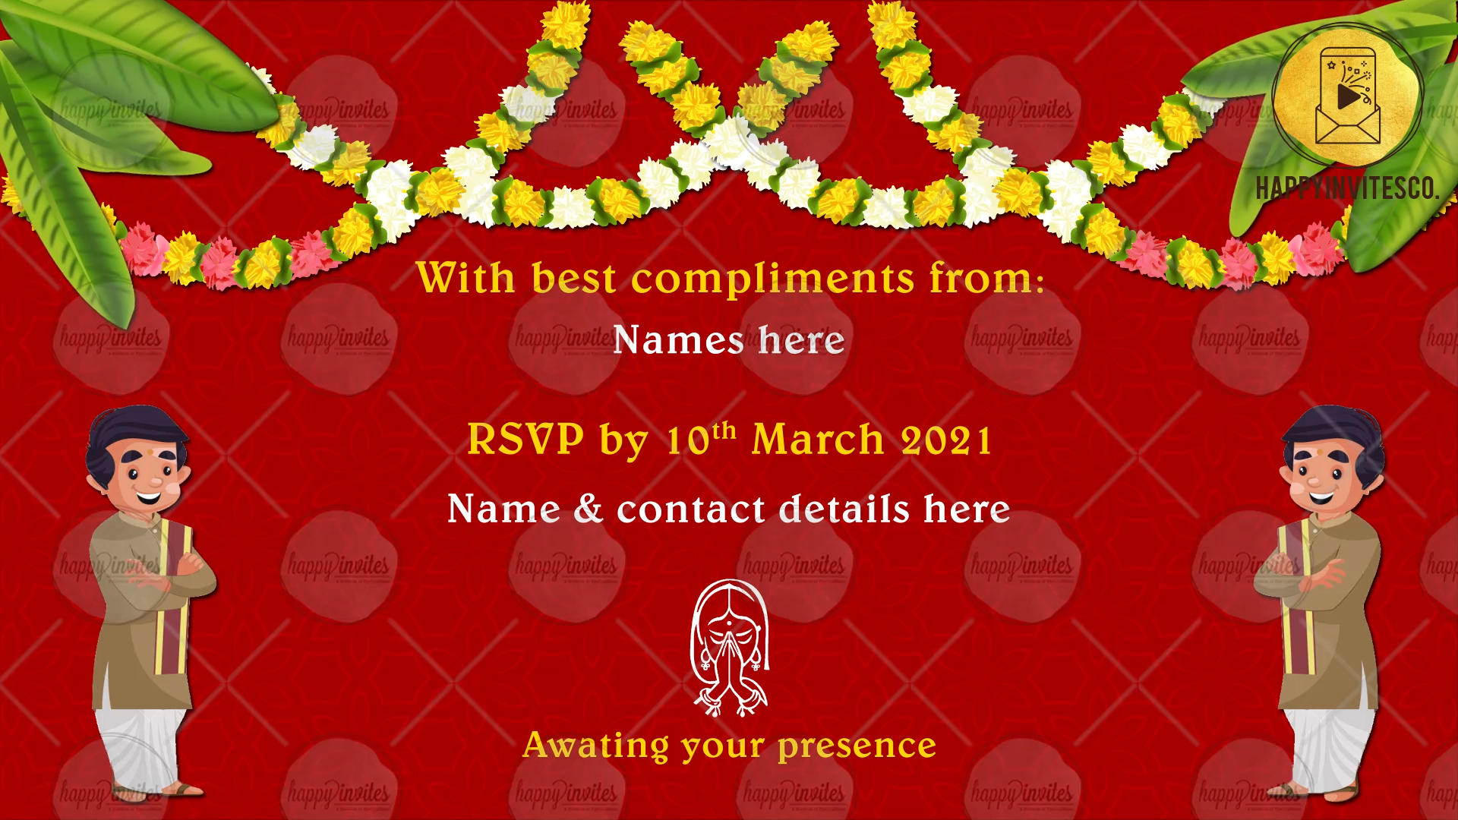
With best compliments from:
Names here
RSVP by 10th March 2021
Name & Contact details here
Awaiting your presence

