EMAIL THIS FORM AFTER FILLING ALL DETAILS ON happyinvites.co@gmail.com.
Please email the photos if needed on the same.
Write NA (not applicable) for pages or lines not needed .

Page 1:
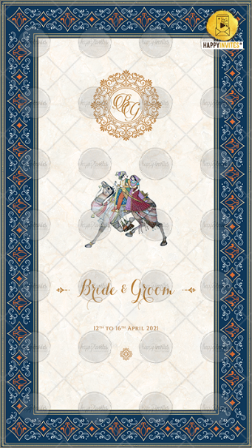
Initals for Logo: BG (If you want to place your logo then please share a PNG image @ happyinvites.co@gmail.com)
Name of Bride:
Name of Groom:
Date:
Whose name should come first (Bride/Groom)?
Page 2:
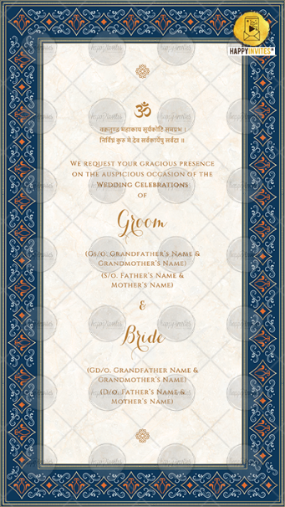
OM Symbol
Vakratunda Shloka

We request your gracious presence
on the auspicious occasion of the
Wedding Celebrations of
Groom
Name of grandparents
Name of parents

&

Bride
Name of grandparents
Name of parents

Page 3:
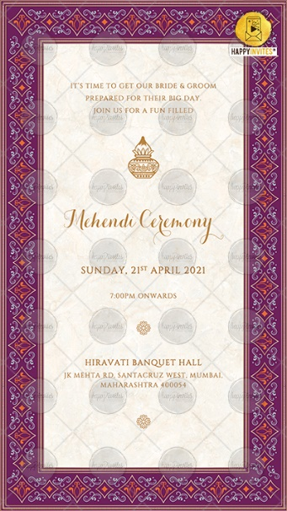
It’s time to get our bride & groom
prepared for their big day.
Join us for a fun filled

Mehendi Ceremony

Day
Date
Time

Venue

Page 4:
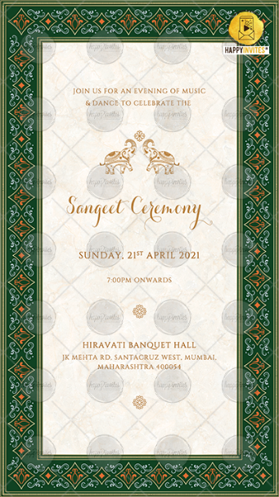
Join us for an evening of music
& dance to celebrate the

Sangeet Ceremony

Day
Date
Time
Venue

Page 5
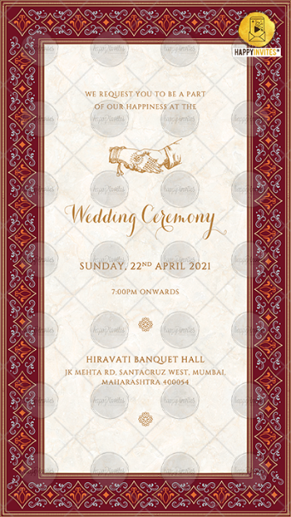
We request you to be a part
of our happiness at the

Wedding Ceremony

Day
Date
Time
Venue

Page 6:
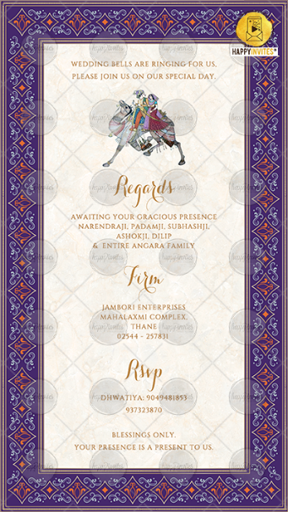
Wedding bells are ringing for us,
Please join us on our special day.

Regards,
Names here

Firm (If Needed)
Rsvp (If Needed)

Blessings only.
Your presence is a present to us.

