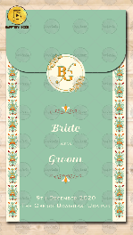
Slide 1:

Email logo on happyinvites.co@gmail.com – Please note it should be an open file like AI or PSD or be a PNG image

Name of Bride:
Weds
Name of Groom:

Mention whose name to come first: Bride or Groom

Wedding Date:
Venue if Destination:

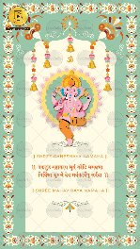
Slide 2:
Ganeshji Image
If you want some other God’s image please share it, we will replace it

|| Shree Ganeshaya Namaha ||

वक्रतुण्ड महाकाय सूर्यकोटि समप्रभ ।
निर्विघ्नं कुरु मे देव सर्वकार्येषु सर्वदा ॥

|| Shree Mahaviraya Namaha ||

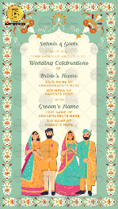
Slide 3:

Name of Family Inviting:

Cordially request
Your gracious presence to

Wedding Celebrations
Of

Name of Bride:
Gd/o.
D/o.

With

Name of Groom:
Gs/o.
S/o.

Slide 4:
Function Title:

Day,
Date

Time

Venue

Slide 5:

Function Title:

Day,
Date

Time

Venue

Slide 6:

Function Title:

Day,
Date

Time

Venue

Slide 7:

Function Title:

Day,
Date

Time

Venue

Slide 8:

Function Title:

Day,
Date

Time

Venue

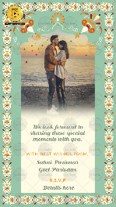
Slide 9:

We look forward to sharing these special moments with you.

With best wishes from,

R.S.V.P.

Email one photo of couple on happyinvites.co@gmail.com

