BT01 - Bollywood Style Wedding Invitation Form
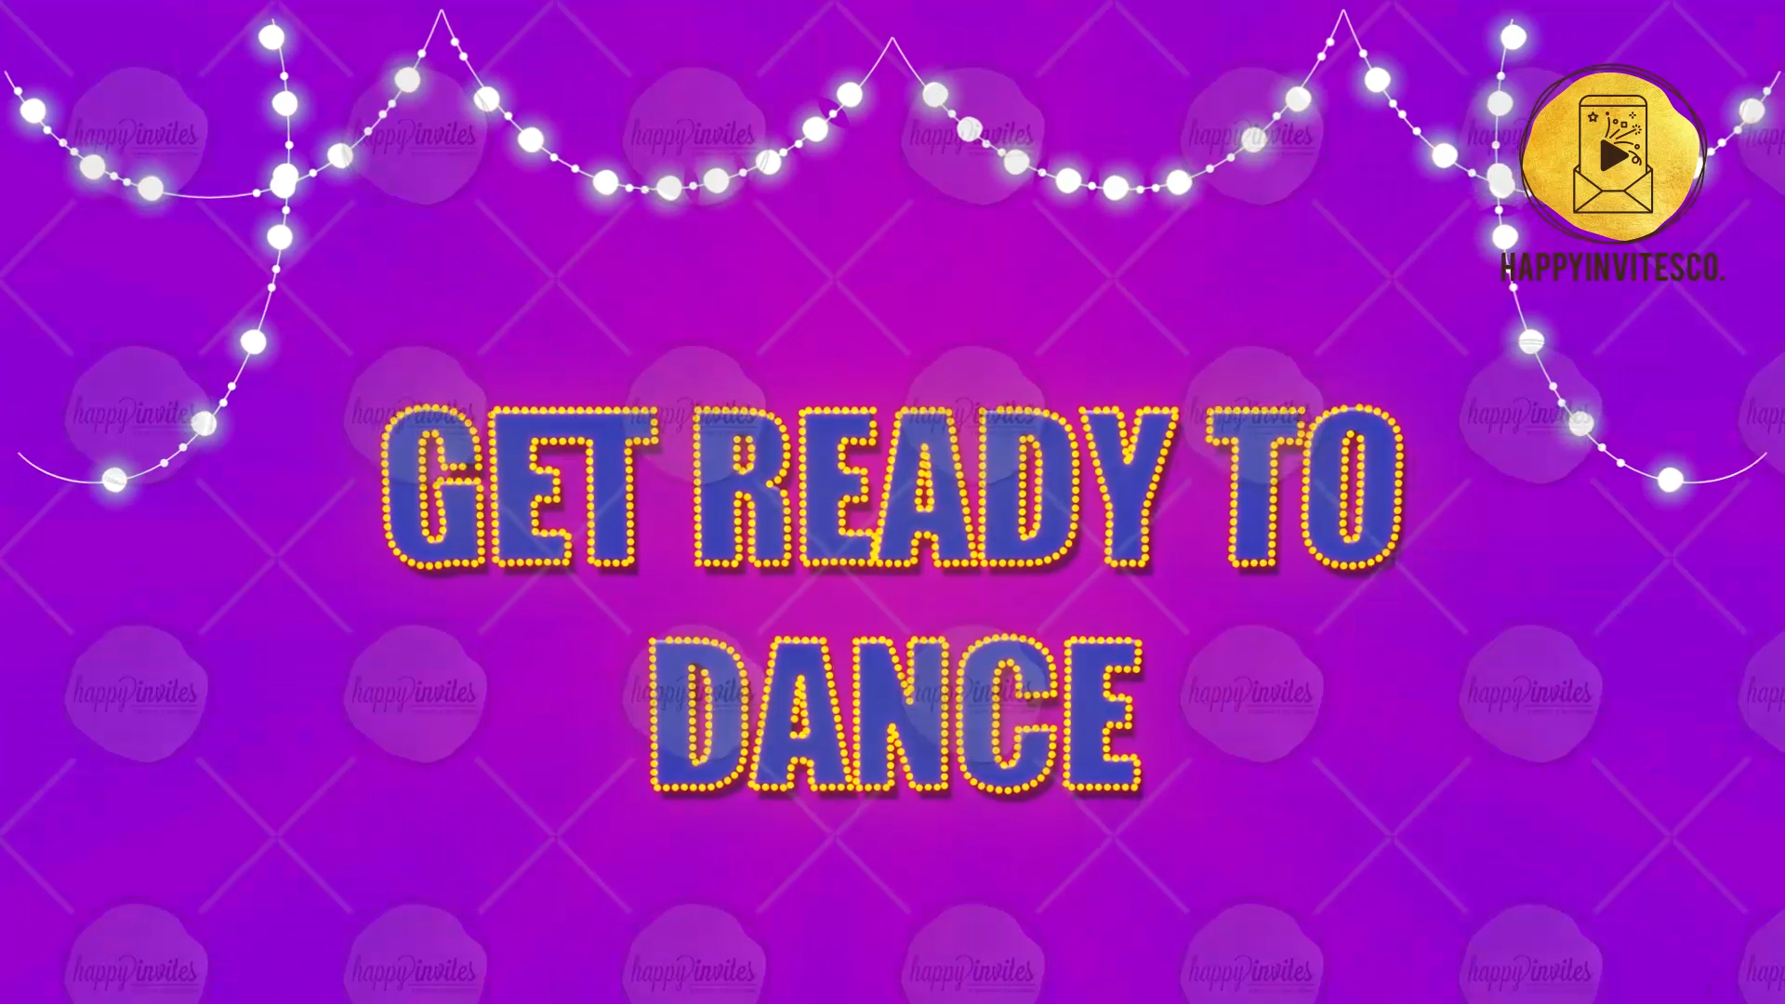
Slide 1:-
Text: Get Ready to Dance
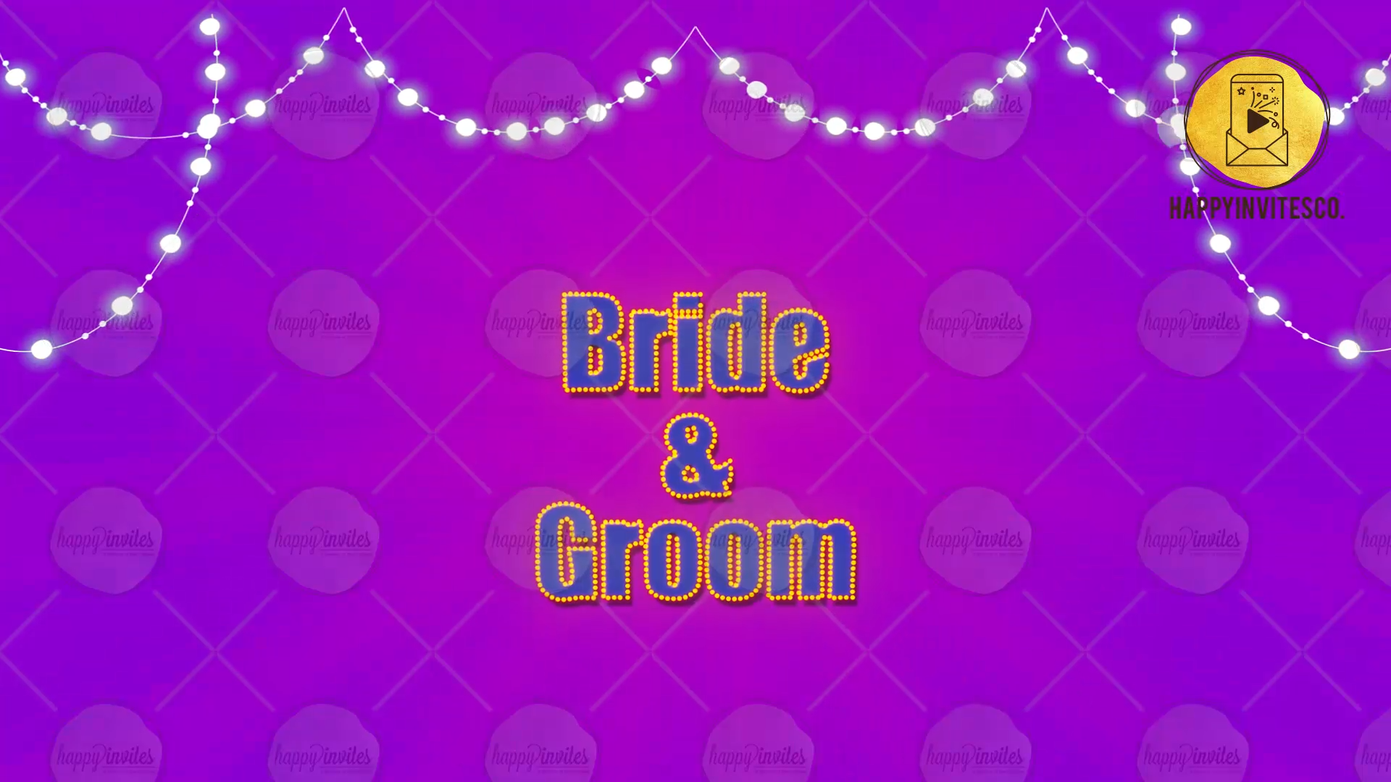
Slide 2:-
Bride Name:
Groom Name:
Whose name should come first:-
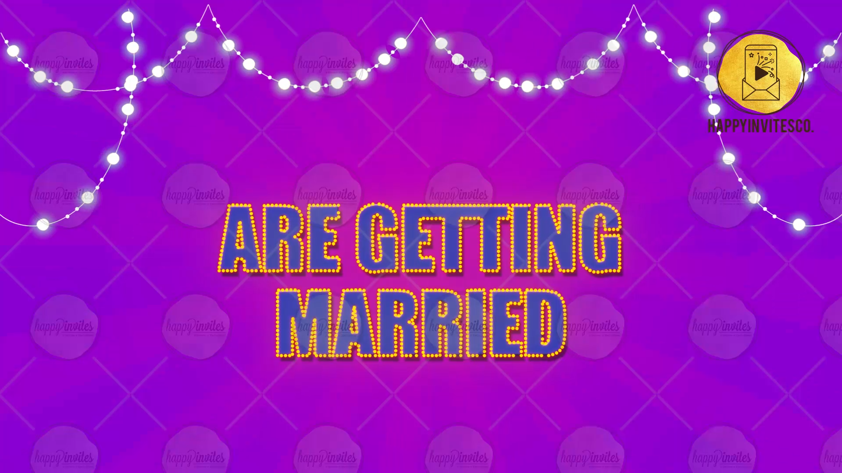
Slide 3:-
Text: are getting married
Slide 4:-
Text: A match made in Heaven
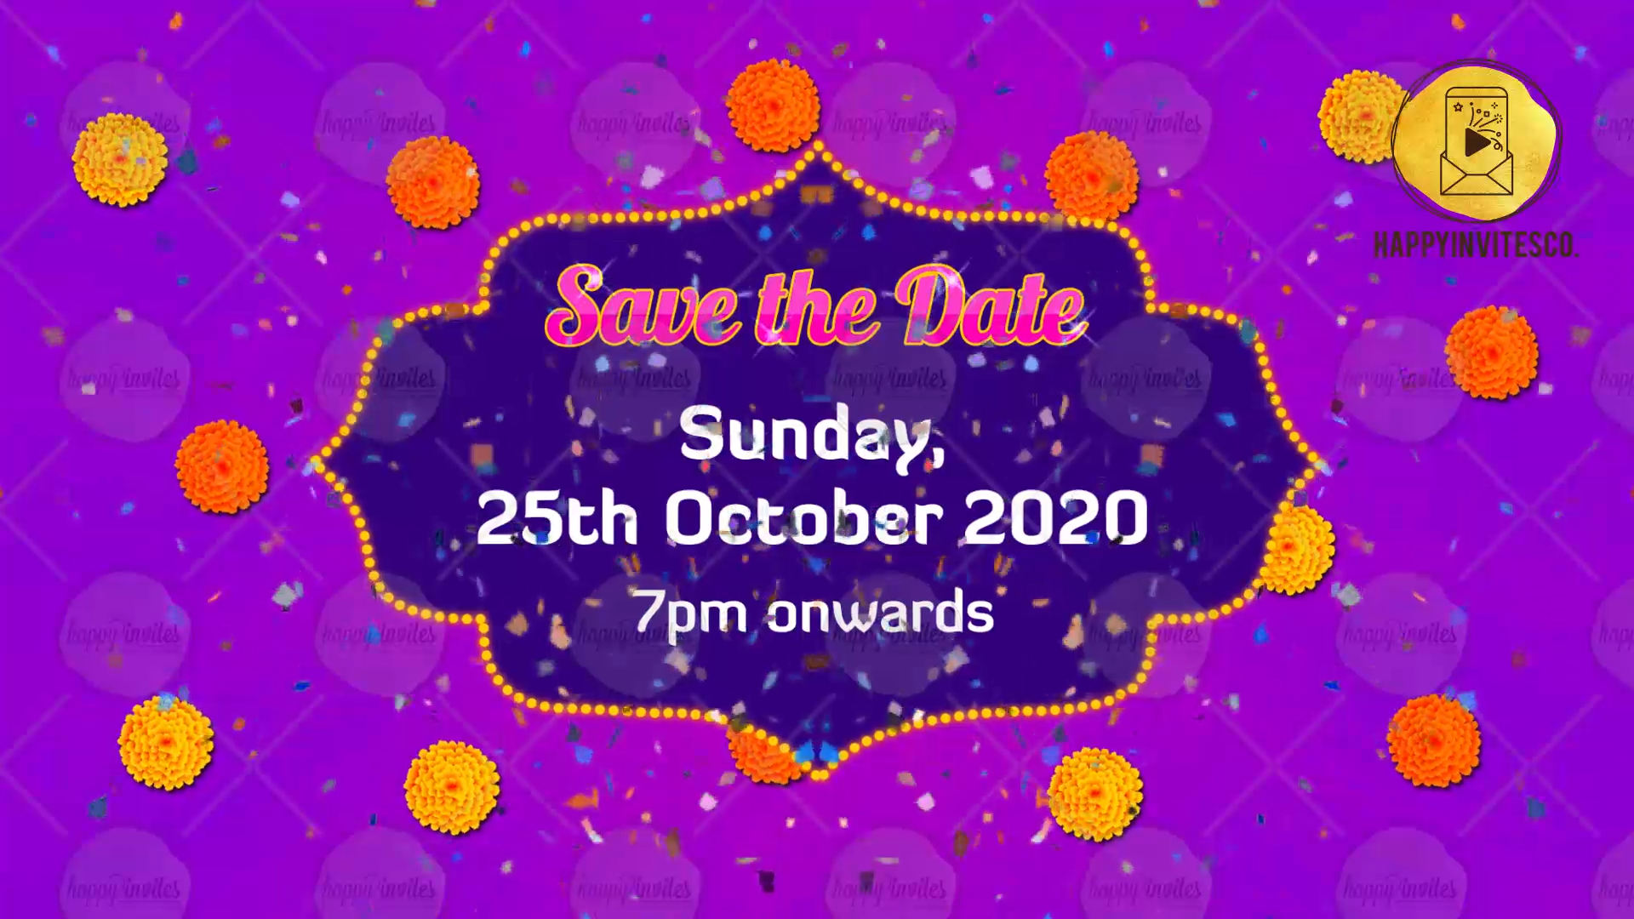
Slide 5:-
Title:- Save the Date
Date:-
Time:-
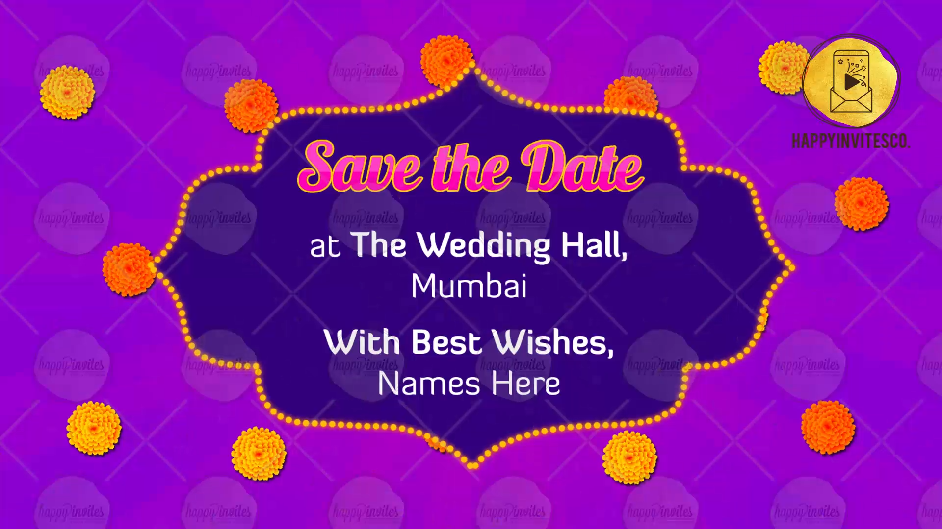
Slide 6:-
Venue:-
With best Wishes:-
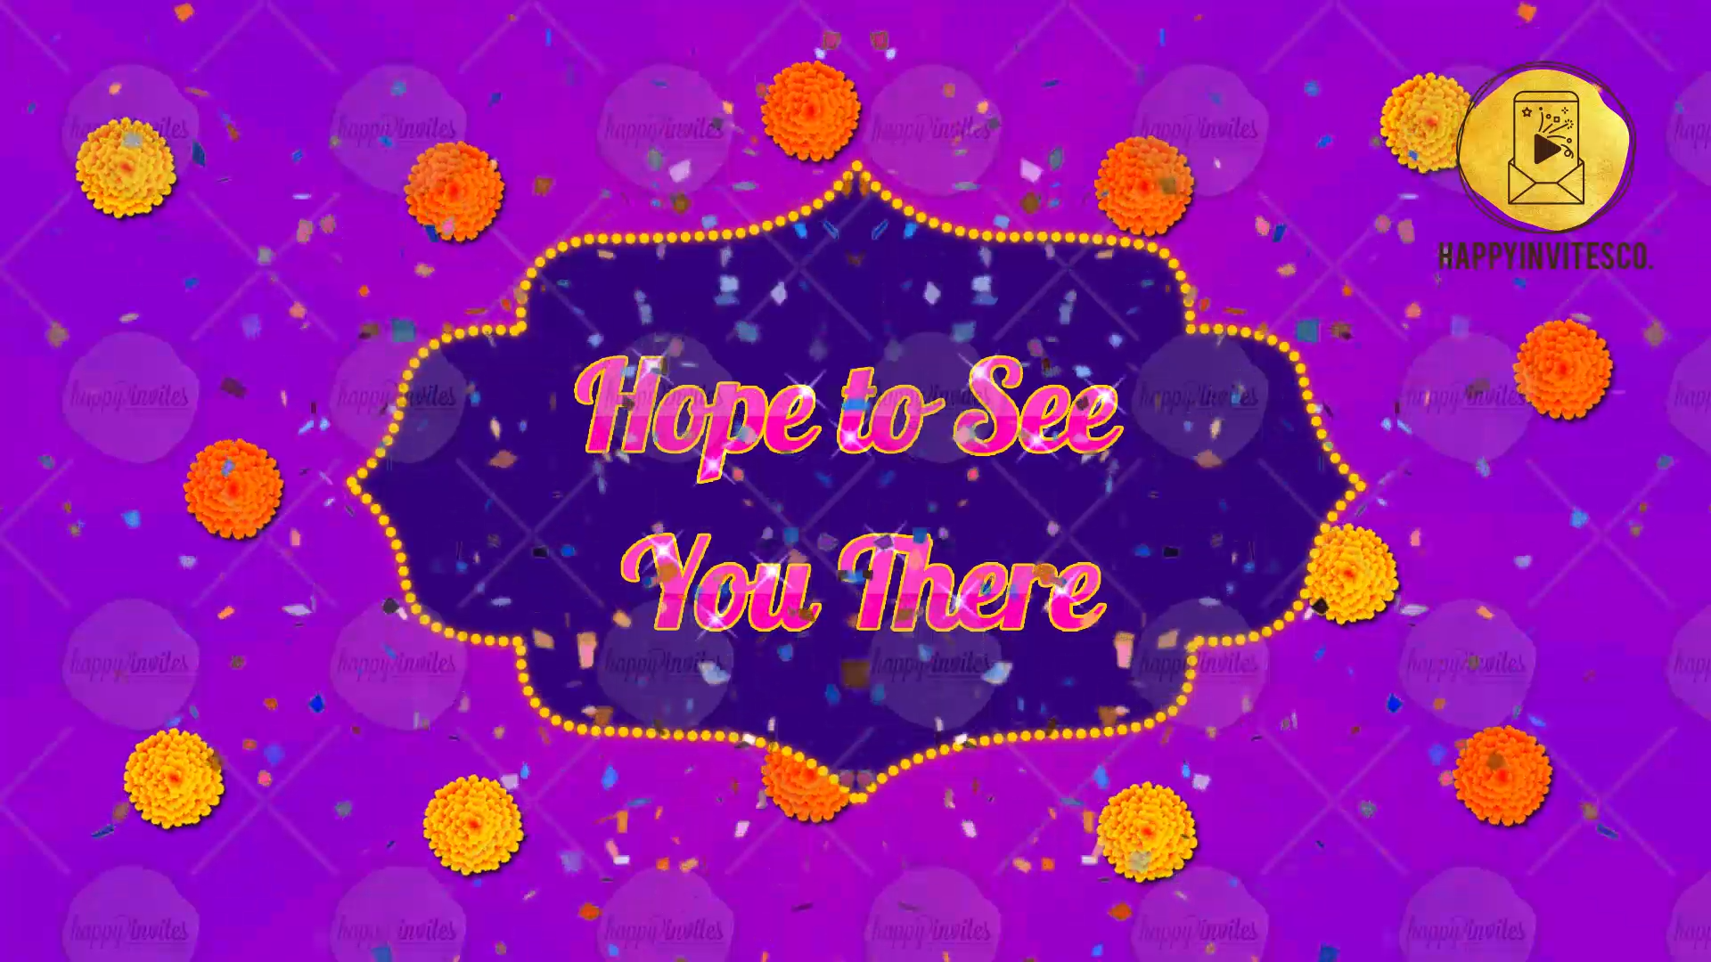
Slide 7:-
Hope to see you there!

