SLIDE 1:-
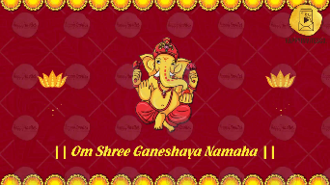
|| Om Shree Ganeshaya Namaha ||
SLIDE 2:-
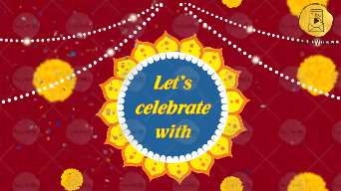
Let’s Celebrate with
SLIDE 3:-
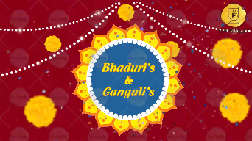
Bhaduri’s & Ganguli’s

SLIDE 4:-
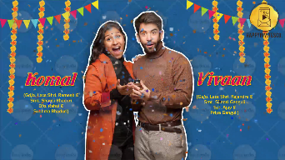
Name of Bride:
Bride’s Parents Name
Bride’s Grand-Parents Name

Name of Groom:
Groom’s Parents Name
Groom’s Grand-Parents Name

Whose name should come first? Bride/ Groom

SLIDE 5:-
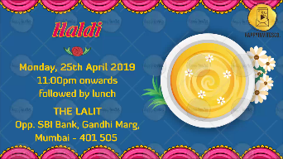
It’s time to get our Bride prepared for her big day
Join us for a fun filled
Name of the Function:
Date:
Time:
Venue:
-

SLIDE 6:-
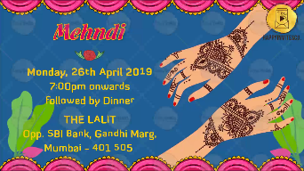
Join us for an evening of Music & Dance to celebrate the
Name of the Function:
Date:
Time:
Venue:
-

SLIDE 7:-
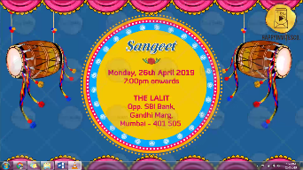
Name of the Function:
Date:
Time:
Venue:
-

SLIDE 8:-
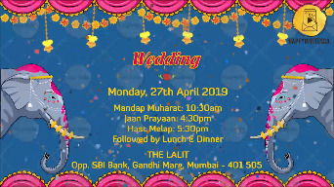
Name of the Function:
Date:
Time:
Venue:
-

SLIDE 9:-
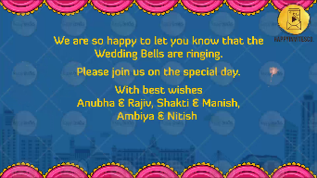
We are so happy to let you know that the
Wedding Bells are ringing
Please join us on the special day.
With best wishes
Names Here
-

SLIDE 10:-
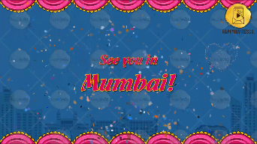
See you in Mumbai!

