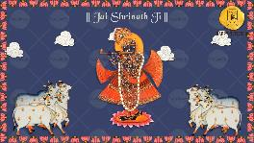
SLIDE 1:

|| Jai Shrinath Ji ||

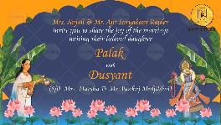
SLIDE 2:

It gives us immense pleasure to
Cordially invite you to the Wedding Celebrations of

Name of Bride
(D/o. Name of parents here)
(Gd/o. Name of grandparents here) – optional

and

Name of Groom
(S/o. Name of parents here)
(Gs/o. Name of grandparents here) – optional

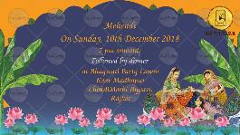
SLIDE 3:

Title of the function: Mandap, etc.
Day, Date:
Time:
Venue:

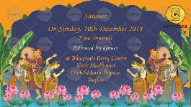
SLIDE 4:

Title of the function: Sangeet
Day, Date:
Time:
Venue:

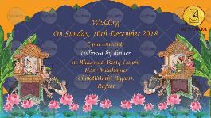
SLIDE 5:

Title of the function: Baraat & Wedding
Day, Date:
Time:
Venue:

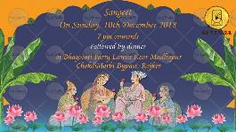
SLIDE 6:

Title of the function: Reception
Day, Date:
Time:
Venue:

SLIDE 7:

Email one photo to be added here in the circle on top on happyinvites.co@gmail.com

Please join us on this special day.

With best compliments from,

Awaiting your presence,

