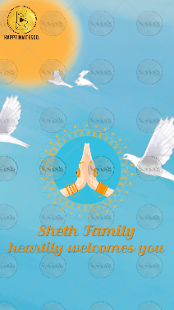
Slide 1:

Sheth Family
welcomes you

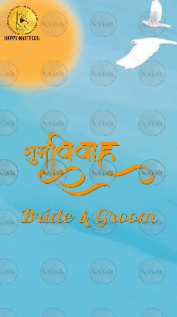
Slide 2:

Name of Bride:
Name of Parents optional:

Name of Groom:
Name of Parents optional:

Whose name should come first: Bride/ Groom:

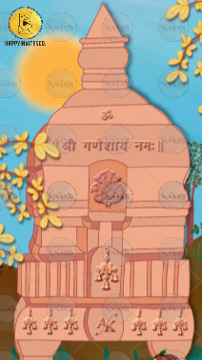
Slide 3:
Icon: Om
Line: || Shree Ganeshaya Namaha ||

Icon: Logo as shared by Bride Groom

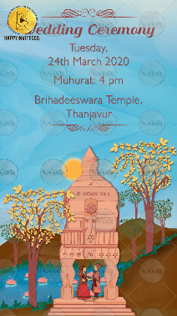
Slide 4:

Title of the function:

Day,
Date
Time
Venue

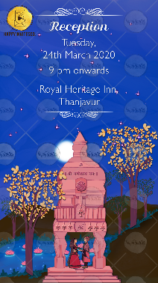
Slide 5:

Title of the function:

Day,
Date
Time
Venue

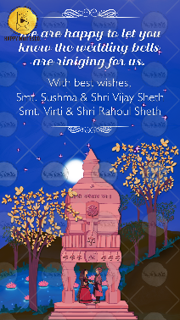
Slide 6:

We are happy to let you know the wedding bells are ringing for us.

With best wishes,
Names here

