SLIDE 1:-
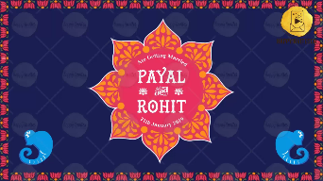
Name of Bride:
Name of Groom:
Whose name should come first? Bride/ Groom

Date of the Function:

SLIDE 2:-
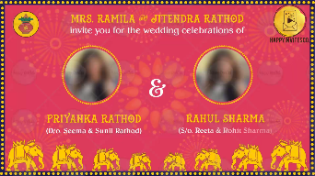
You are invited for the Wedding Celebrations of
Name of Bride:
Grandparents Names:
Parents Names:

Name of Groom:
Grandparents Names:
Parents Names:

SLIDE 3:-
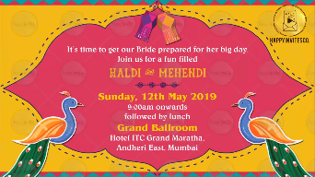
It’s time to get our Bride prepared for her big day
Join us for a fun filled
Name of the Function:
Date:
Time:
Venue:
-

SLIDE 4:-
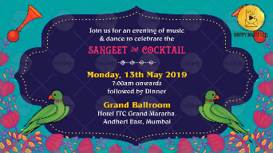
Join us for an evening of Music & Dance to celebrate the
Name of the Function:
Date:
Time:
Venue:
-

SLIDE 5:-
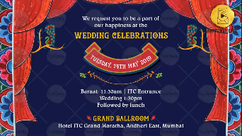
Name of the Function:
Date:
Time:
Venue:
-

