BP 17 - Green Invitation Form

MATTER FOR SLIDE 1
-

MATTER FOR SLIDE 2
-
MATTER FOR SLIDE 3
-
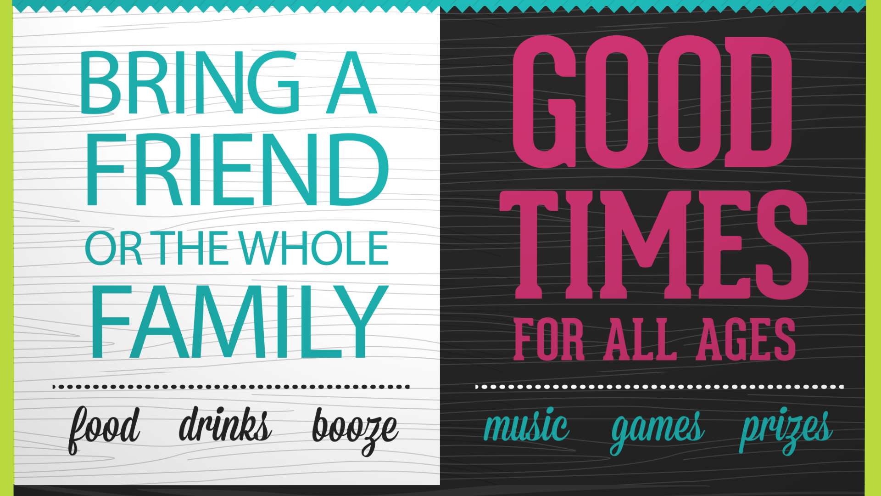
MATTER FOR SLIDE 4
-
MATTER FOR SLIDE 5
-
MATTER FOR SLIDE 6
-
MATTER FOR SLIDE 7
-
MATTER FOR SLIDE 8

