PAGE 1:

Icon if the God you wish to show
Title: ||Om Shree Ganeshaya Namha ||

Name of Bride:
weds
Name of Groom:

Please mention whose name should come first: Bride or Groom

Date Range or Wedding Date:

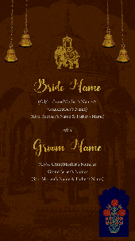

PAGE 2:

We request the pleasure of your presence
on the auspicious occasion of the
Wedding Celebrations
of

Name of Bride:
Name of Grandparents:
Name of Parents:

With

Name of Groom:
Name of Grandparents:
Name of Parents:

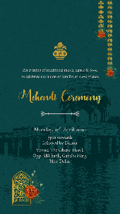

PAGE 3:

An evening of traditional music, dance & food
to celebrate the union of family & friends

or

“When Mehendi adorns the hands, life takes a new colour.”

Title of the Function:

Day, Date:

Time:

Venue:

PAGE 4:

“Swaying through the night they realised that,
life is going to be the biggest party they will ever attend.”

Title of the Function:

Day, Date:

Time:

Venue:

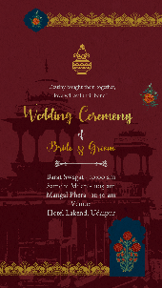

PAGE 5:

“Destiny brought them together,
love will seal their bond Forever.”

Title of the Function:

Day, Date:

Time:

Venue:

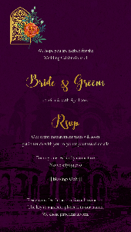

Page 6:

“The wedding bells are ringing for us.
Please join us on our special day.”

Names of family members category wise (optional)

With best wishes,
Names here

RSVP:
Details here

|| Blessings Only ||

Icon of hands joined

Please consider this as our formal invitation.
The key to a greener planet is in our hands. We chose paperless invites.

