EMAIL THIS FORM AFTER FILLING ALL DETAILS ON happyinvites.co@gmail.com.
Please email the photos if needed on the same.
Write NA (not applicable) for pages or lines not needed .

PAGE 1

Your God’s Name:
|| Om Shree Ganeshaya Namaha ||

The default logo as shown or your logo
(For your logo please email the open file or Transparent Background High resolution PNG)

Name of Bride:
Name of Groom:
Whose name to come first?

Wedding Date:
Venue:

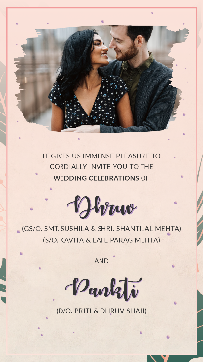
PAGE 2

It gives us immense pleasure to
cordially invites you to the

Wedding Celebrations
of

Groom
Name of grandparents
Name of parents

&

Bride
Name of grandparents
Name of parents

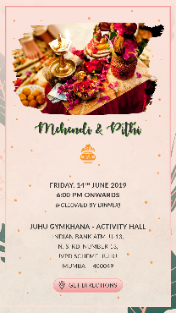
PAGE 3

Title of the function

Day
Date
Time

Venue

Google map link url:

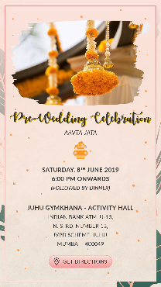
PAGE 4

Title of the function

Day
Date
Time

Venue

Google map link url:

PAGE 5

Title of the function

Day
Date
Time

Venue

Google map link url:

PAGE 6

Title of the function

Day
Date
Time

Venue

Google map link url:

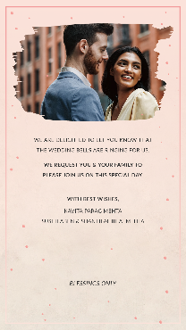
PAGE 7

We are delighted to let you know that
The Wedding bells are ringing for us.

We request you & your family to
please join us on our special day.

With best wishes,

Blessings only.

