HW05A - Text Matter Flow

SLIDE 1:
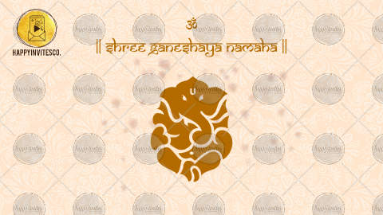

Text 1 (Opening Slide)
Let the default text be there or replace it with the text of your choice:

|| Om Shree Ganeshaya Namaha ||

-

Paste the url/ link of the image, if you wish to replace it. (It needs to be a PNG image with transparent background, else we shall not be able to use it)

-

SLIDE 2:
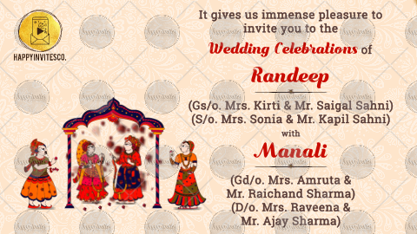

Invitation Msg:

It gives us immense pleasure to invite you to the

Wedding Celebrations of

Groom's Name:
Groom's Parents' Names (optional):
Groom's Grandparents' Names (optional):

With

Bride's Name:
Bride's Parents' Names (optional):
Bride's Grandparents' Names (optional):

Whose name needs to come first? GROOM/ BRIDE

-

SLIDE 3:
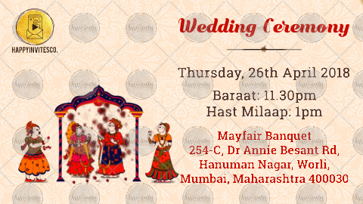

FUNCTION TITLE: Wedding Ceremony

DATE/ DATES:

TIME:

VENUE:

-

SLIDE4:
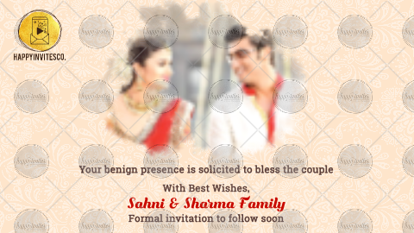

Share photo on happyinvites.co@gmail.com.

Invitation Msg: (Could be; 'We look forward to seeing you' or 'With best wishes' or 'Eagerly await your arrival' or 'With best regards' or matter of your choice)

We look forward to seeing you

With best wishes,
Parents/ Grandparents/ Family Surnames:

RSVP Details (Optional)
Any other lines if you wish to add, can also be mentioned here

