DW02P – Text Matter Flow

SLIDE 1:
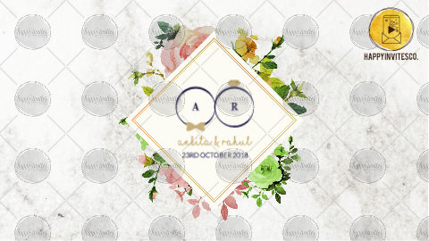

Groom's Name:
Bride's Name:

Whose name needs to come first?
Groom/ Bride

WEDDING DATE / DATE RANGE:

-

SLIDE2:
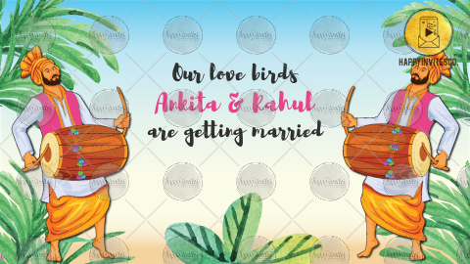
LINE 1:
Our love birds (optional)
Name of Bride & Groom

Whose name needs to come first?
Groom/ Bride

are getting married

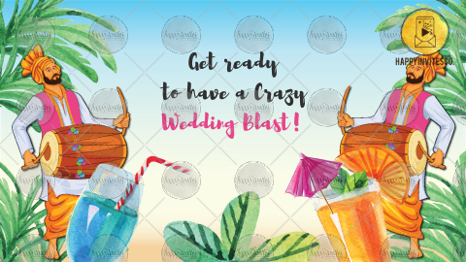
LINE 2:
Get ready
to have a Crazy
Wedding Blast!

-

SLIDE3:
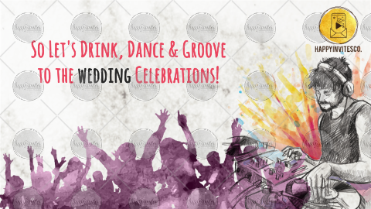
So Let’s Drink, Dance & Groove
to the Wedding Celebrations!

Or Please share your matter here

-

SLIDE4:
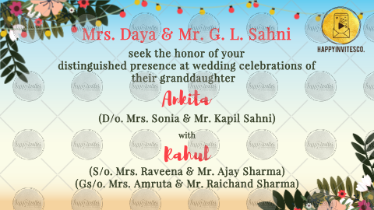

Inviting Grandparents/ Parents Names:

Seek the honour of your
distinguished presence at Wedding Celebrations of
their granddaughter/ daughter/ grandson/ son

Name of the Bride/ Groom
Name of Parents (if not given above)

With

Name of Bride/ Groom
Name of Grandparents (optional)
Name of Parents

-

SLIDE5:
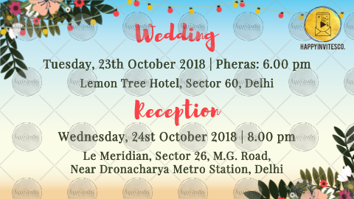
Function Title: Wedding or your preference
Date
Time
Venue

Function Title 2: Reception or your preference]Date
Time
Venue

-

SLIDE6:
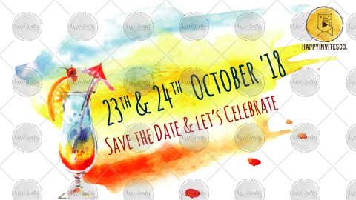
YOUR DATES
Save The Date & Let’s Celebrate

OR

We look forward to seeing you
Names of the Family/ Surnames

RSVP (Optional)

