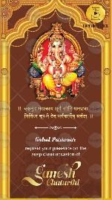
Slide 1:

Vakratunda shloka comes
-

Gohel Parivaar

request your presence on the
auspicious occasion of

Ganesh Chaturthi

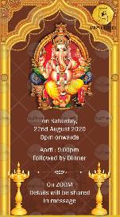
Slide 2:

On Saturday,
Date

Time

Venue

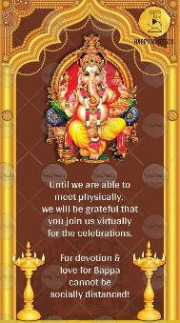
Slide 3:

Kindly join us to seek Bappa’s blessings.

With best wishes,

