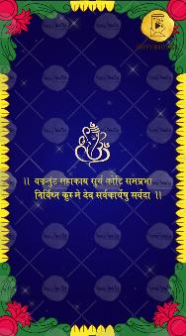
Slide 1:
Ganeshji Icon
Vakratunda shloka

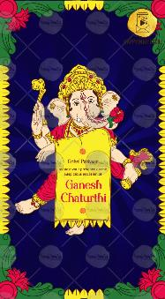
Slide 2:
Gohel Parivar

Requests your gracious presence on the
Auspicious occasion of

Ganesh
Chaturthi

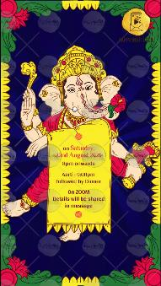
Slide 3:

On Day, Date;

Time:

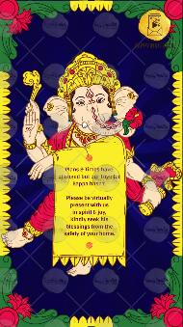
Slide 4:

Venue:

With best wishes,

