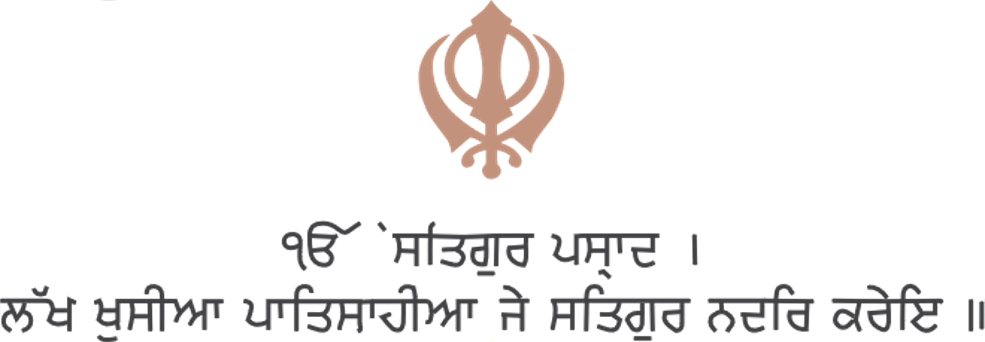

Singh Family
heartily invites you to join them for

Shri Sukhmani Sahib Path
followed by Kirtan & Langar

to celebrate

Prabjot Singh’s 1st Birthday!

(Grandson of Mrs. Harpreet & Guru Singh)
(Son of Ashni & Rahul Singh)

Tuesday, 28th May 2019
11:30 am to 12:30 pm

Venue: LADY MARAGARET ROAD,
SOUTHHALL, UBI 2RH.

Programme
Sukhmani Sahib Path -
Kirtan & Ardaas -
Followed by Guru Ka Langar -

With best compliments
Plaha & Singh family, all relatives & friends

R.S.V.P
Harpinder Singh: 8879794909
Dear Margaret Rd, Southall, UBI 2RH

