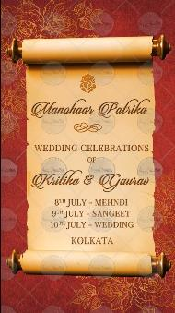

Name / Icon of God:

Opening Title: Manohaar Patrika

Title of Function: Wedding Celebrations
Of
Name of Groom:
Name of Bride:
Whose name to come first? Bride or Groom

Date/Dates Range:
Venue:

Page 2:

With best wishes,
Names here

RSVP (Optional)

