MF14 - The Wedding Story of Simple Cute Couple

Slide 1:
This is the story of
Name of Bride:
Name of Groom:
Whose name should come first: Please mention Bride/ Groom?

PLEAS MENTION NUMBERS FOR GROOM
PLEASE MENTION NUMBER FOR BRIDE
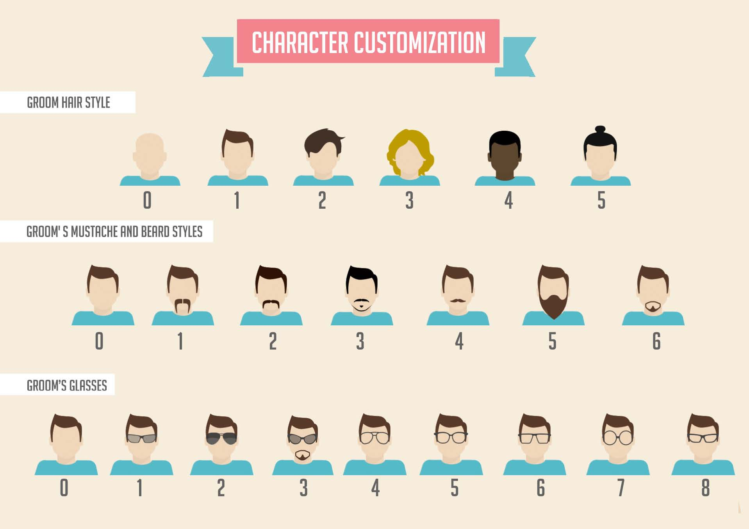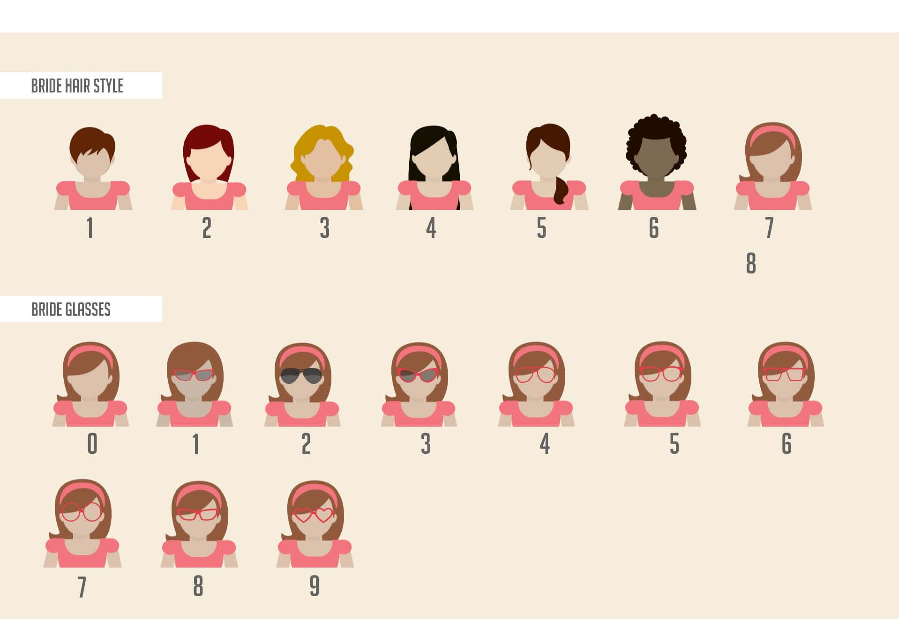

Slide 2:
TEXTBOX 1: It all started when they first met on
TEXTBOX 2: 20th June 2016 – In college campus

Slide 3:
TEXTBOX 3: It has been a beautiful journey since their first date
TEXTBOX 4: 1st September 2016 – ‘La La Land’ at Imax Movie Cinemas

Slide 4: Email photos of 2 places on happyinvites.co@gmail.com
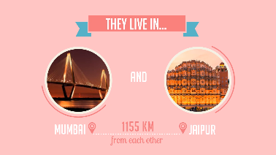
TEXTBOX 5: They live in…
TEXTBOX 6: Name of Place 1
TEXTBOX 7: Name of Place 2
TEXTBOX 8: Distance to be mentioned here
TEXTBOX 9: from each other

Slide 5: Email photos of Bride & Groom on happyinvites.co@gmail.com
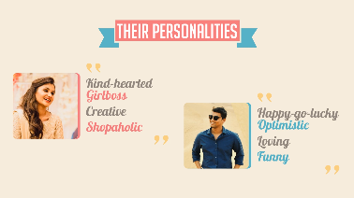
TEXTBOX 10: Their Personalities
TEXTBOX 11: 4 Qualities of Bride
TEXTBOX 12: 4 Qualities of Groom

Slide 6:
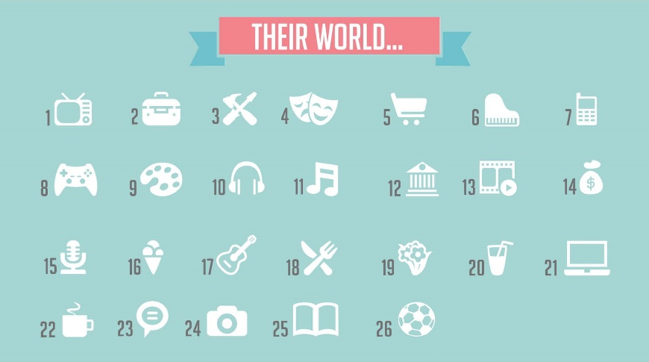
TEXTBOX 13: Their Worlds…

Please Provide 5 Numbers based on choice of Icons for Bride:
Please Provide 5 Numbers based on choice of Icons for Groom:

Slide 7:
TEXTBOX 14: DAYS/ YEARS OF DATING:
TEXTBOX 15: MENTION THE NUMBER IN DAYS/ YEARS

Slide 8:
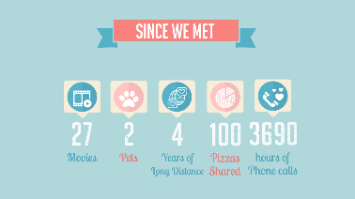
TEXTBOX 16: SINCE WE MET
15 Movies (2)
7 Friends Married (3)
20 Songs sung together (8)
2 Pets (6)
50 Pizzas Shared (12)

--- You can choose your number and mention it here & give your lines and icon if you wish –
Slide 9:
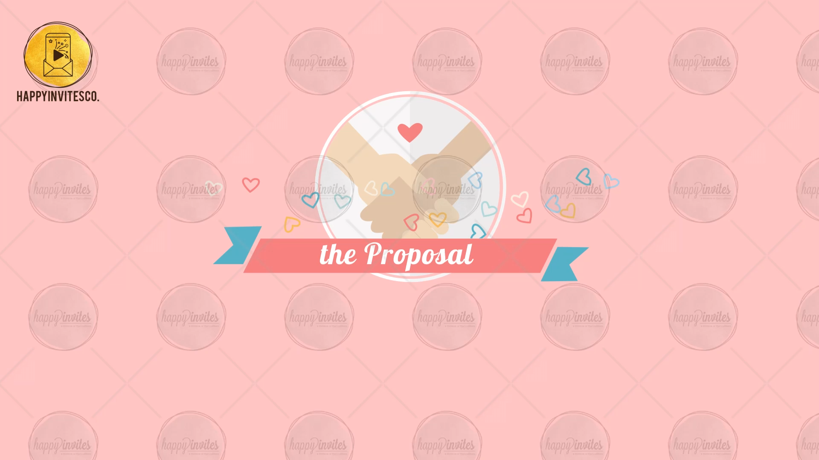
TEXTBOX 17: FEW YEARS LATER…
TEXTBOX 18: THE PROPOSAL
TEXTBOX 19: WILL YOU MARRY ME? YES!

Slide 10:
TEXTBOX 20: SAVE THE DATE
TEXTBOX 21: for the Wedding Celebrations of
TEXTBOX 22: Name of Bride & Groom
TEXTBOX 23: DATE TO BE MENTIONED HERE WITH THE DAY

Slide 11:
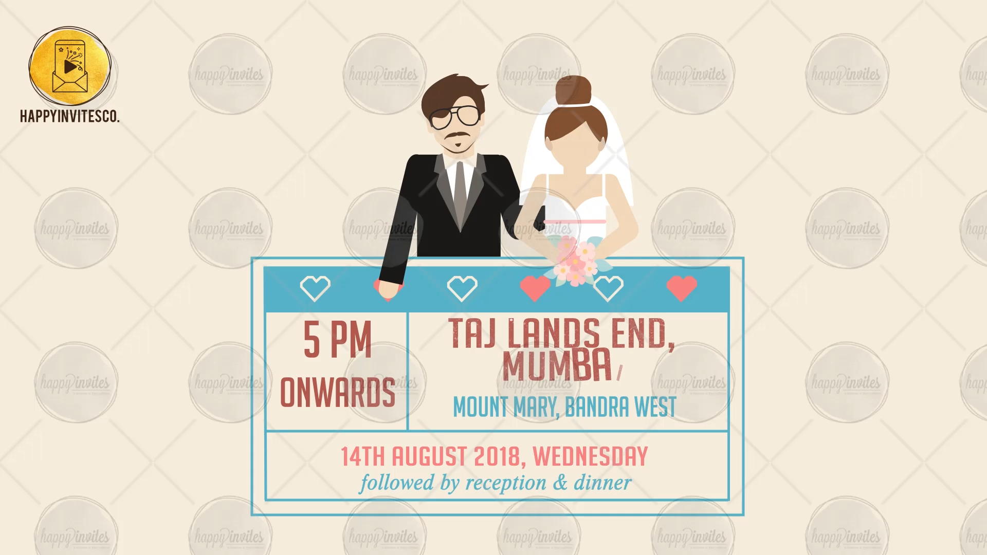
TEXTBOX 24: TIME OF THE OCCASION
TEXTBOX 25: VENUE TO BE MENTIONED HERE
TEXTBOX 26: DATE TO BE MENTIONED HERE WITH THE DAY

Slide 12: Email photo of Bride & Groom on happyinvites.co@gmail.com
TEXTBOX 27: HAPPY TO SHARE OUR DAY WITH YOU
TEXTBOX 28: WE LOOK FORWARD TO SEEING YOU
TEXTBOX 29: NAMES OF THE INVITERS OR THE FAMILY SURNAMES
TEXTBOX 30: RSVP DETAILS HERE

