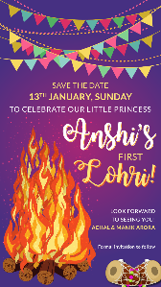

Top Line:
SAVE THE DATE

Day, Date:
Time:

Line Invite:
To celebrate our Little Princess

Function Title:
Anshi’s First Lohri

Venue:

Last line:
Look forward to see seeing you!
Names here

Optional: Formal Invitation to follow

