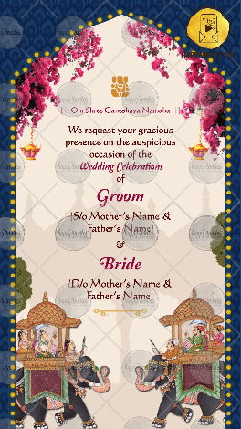
SLIDE 1:

Ganeshji Icon
|| Om Shree Ganeshaya Namaha ||

We request your gracious presence on the
auspicious occasion of the
Wedding Celebrations
of

Groom
(Name of Parents here)

&

Bride
(Name of Parents here)

- Kindly check the Mr. / Mrs. / Shri / Smt. if to be added

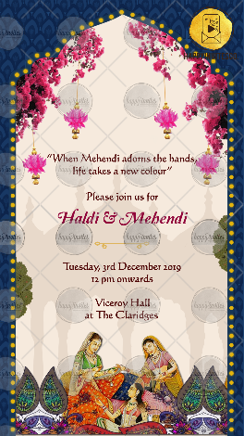
SLIDE 2:

“When Mehendi adorns the hands,
Life takes a new colour”

Please join us for
Function Title

Day, Date
Time

Venue

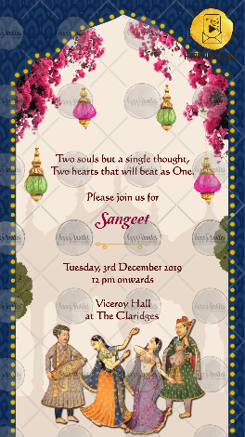
SLIDE 3:

“Two sould but a single thought,
Two hearts that will beat as One.”

Please join us for
Function Title

Day, Date
Time

Venue

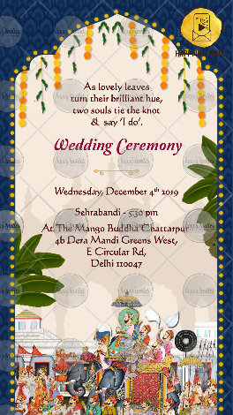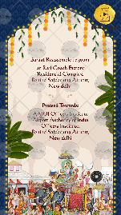
This Slide 4b is optional if your matter is that much then you can share the content, else will be removed

SLIDE 4:

As lovely leaves
turn their brilliant hue,
two sould tie the knot
& say ‘I do’.

Function Title

Day, Date
Time

Venue

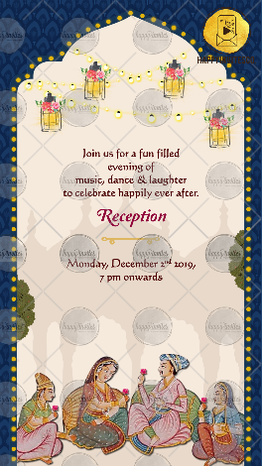
SLIDE 5:

Join us for a fun filled
Evening of
Music, dance & laughter
To celebrate happily ever after.

Function Title

Day, Date
Time

Venue

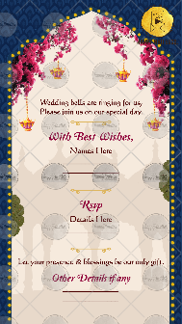
SLIDE 6:

Wedding bells are ringing for us,
Please join us on our special day.

With best wishes,
Names here

RSVP
Details here

Let your presence & blessings be our only gift.

