RHW – Animated Hindu Wedding Invitation

Slide 1: Vakratunda Shloka music
|| Om Shree Ganeshaya Namaha ||

Slide 2:

We cordially invite you
on the auspicious occasion
of the Wedding ceremony
of

Name of Bride
Gd/o. Name of grandparents
D/o. Name of Parents

With

Name of Groom
Gs/o. Name of grandparents
S/o. Name of Parents

Slide 3:

When Mehendi adorns the hands,
Life takes a new colour.

Title of the Function:
Day, Date:
Time:
Venue:

Slide 4:

Two souls but a single thought,
Two hearts that beat as one.

Title of the Function:
Day, Date:
Time:
Venue:

Slide 5:

Let the colour of sunshine bring happiness
In the couple’s new beginning.

Title of the Function:
Day, Date:
Time:
Venue:0

Slide 6:

Let’s get the celebrations started,
By kicking’ up our heels & grooving’ at

Title of the Function:
Day, Date:
Time:
Venue:

Slide 7:

Destiny brought them together
& now Love will seal their bond Forever…

Title of the Function:
Day, Date:
Time:
Venue:

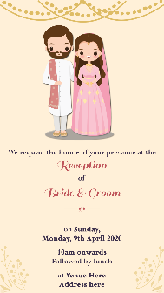
Slide 8:

Cheers to love, laughter & Happily Ever After.

Title of the Function:
Day, Date:
Time:
Venue:

Slide 9:

Plans have changed,
but our love has not!

With best wishes,

RSVP

Email us 1 photo at happyinvites.co@gmail.com

