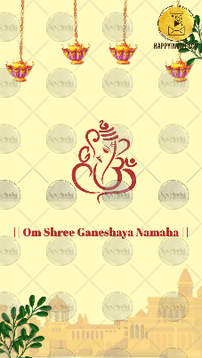
Slide 1:
|| Om Shree Ganeshaya Namaha ||

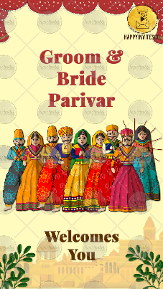
Slide 2:
Bride & Groom
Parivar
Welcomes You

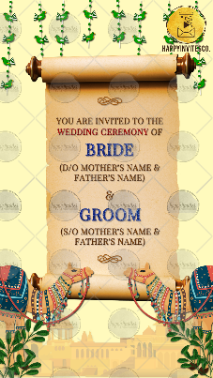
Slide 3:
You are invites to the
Wedding Ceremony of

Bride
(Name of Parents)

&

Groom
(Name of Parents)

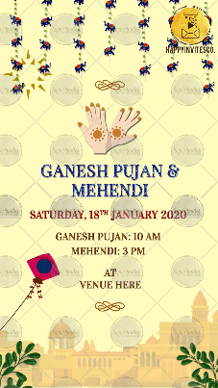
Slide 4:
Title of the function:
Day, Date:
Time:
Venue:

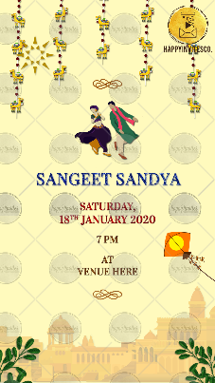
Slide 5:
Title of the function:
Day, Date:
Time:
Venue:

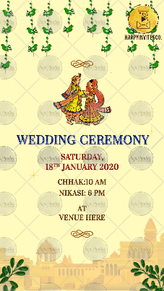
Slide 6:
Title of the function:
Day, Date:
Time:
Venue:

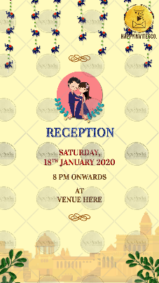
Slide 7:
Title of the function:
Day, Date:
Time:
Venue:

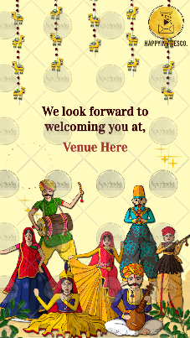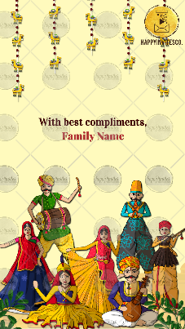
Slide 8:
With best compliments,

