HW16 - Rajasthani Marwari Wedding Invitation Form

Slide 1:
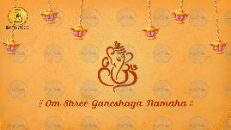
Om Shree Ganeshaya Namaha

-

Slide 2:
Name of Bride:
&
Name of Groom:
are getting married

Whose name should come first: Bride/ Groom

Date range:

-

Slide 3:
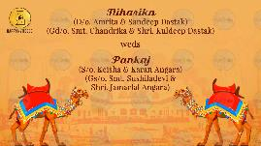
Name of Bride:
Parents names:
Grandparents names (optional)

Weds

Name of Groom:
Parents names:
Grandparents names (optional)
Whose name should come first: Bride/ Groom

-

Slide 4:
Title of the Function: Mehendi

Date:
Time:
Venue:

-

Slide 5:
Title of the Function: Tilak & Sangeet

Date:
Time:
Venue:

-

Slide 6:

Title of the Function: Haldi

Date:
Time:
Venue:

-

Slide 7:
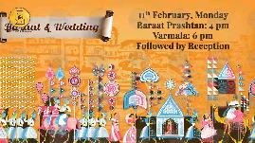

Title of the Function: Barat & Wedding

Date:
Time:
Venue:

-

Slide 8:

See you at!
Name of Venue/ Resort

We look forward to seeing you,
Name of invitees

RSVP.:

-

Slide 9:

Email all photos on happyinvites.co@gmail.com

Please consider this as our personal formal invitation

