HW14 FORM

Slide1:

|| Om Shree Ganeshaya Namaha||

Slide2:
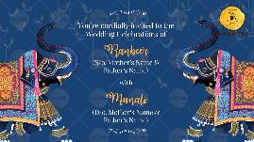

Let's Celebrate The Most
Beautiful
Wedding

You're cordially invited to the
Wedding Celebrations of

Name of Groom
(S/o. Name of parents)

With

Name of Bride
(D/o. Name of parents)

Slide 3:
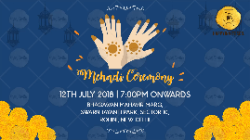
Function Title:
Date:
Time:
Venue:

Slide 4:
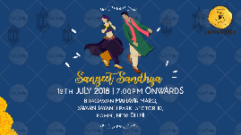
Function Title:
Date:
Time:
Venue:

Slide 5:
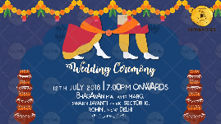
Function Title:
Date:
Time:
Venue:

Slide 6:
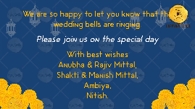

We are so happy to let you know that wedding bells are ringing for us.
Please join us on this special day.

With best wishes,

RSVP info. If any.

